GOVERNMENT POLYTECHNIC, DHANGAR

Branch: Mechanical Engineering Semester: 3rd
Subject: Applied Mechanics Chapter 1: Introduction Chapter 2: Laws of Forces Chapter 3: Moment

Chapter 1 Introduction

INTRODUCTION

Mechanics is the physical science concerned with the behavior of bodies that are acted upon by forces.
Statics is the study which deals with the condition of bodies in equilibrium subjected to external forces.
In other words, when the force system acting on a body is balanced, the system has no external effect on the body, the body is in equilibrium.
Dynamics is also a branch of mechanics in which the forces and their effects on the bodies in motion are studied. Dynamics is sub-divided into two parts: (1) Kinematics and (2) Kinetics
Kinematics deals with the geometry of motion of bodies without and application of external forces.
Kinetics deals with the motion of bodies with the application of external forces.

SOME BASIC TERMS USED IN MECHANICS

The followings are the basic terms which are used in mechanics:

Mass: The quantity of the matter possessed by a body is called mass. The mass of a body can not change unless the body is damaged and part of it is physically separated.

Length: It is a concept to measure linear distances.

Time: Time is the measure of succession of events. The successive event selected is the rotation of earth about its own axis and this is called a day.
Space: Any geometric region in which the study of a body has been done is called space.
Displacement: It is defined as the distance moved by a body/particle in the specified direction.
Velocity: The rate of change of displacement with respect to time is defined as velocity.
Acceleration: It is the rate of change of velocity with respect to time.

UNITS AND DIMENSIONS OF QUANTITIES

Units

Measurements are always made in comparison with certain standards. For example, when we say that cloth piece is 2.5 meters long, the measurement of length is with respect to a scale on which graduations are marked. In turn, the graduation of the scale must have been made according to a national or an international standard. The standard so chosen for the measurement of length is called the unit of length. In this example, ‘metre’ is the unit of length.
Similarly, for the measurement of time, weight, current, speed etc, different units are used.
Each physical quantity is measured for the purpose of analysis, study, comparison, experimentation/results, design etc. with the help of measuring units by comparison.

There are four systems of units used for the measurement of physical quantities. viz. FPS (Foot – Pound – Second) system, CGS (Centimeter – Gram – Second) system, MKS (Meter - Kilogram – Second) system and SI (System international dꞌunits – the French name)
The SI system of units is said to be an absolute system.

S.I Units (International System of Units)

The fundamental units of the system are metre (m) for length, kilogram (kg) for mass and second (s) for time.
The unit for force is newton (N). One newton is the amount of force required to induce an acceleration of 1 m/sec2 on one kg mass.
Weight of a body (in N) = Mass of the body (in kg ) × Acceleration due to gravity (in m/sec2).

Dimensions

The branch of mathematics dealing with dimensions of quantities is called dimensional analysis. There are two systems of dimensional analysis viz. absolute system and gravitational system.

Absolute system (MLT system)

A system of units defined on the basis of length, time and mass is referred to as an absolute system.
According to SI system of units, three basic units metre, second and kilogram can be used. In MLT system, M refers to Mass, L refers to Length and T refers to Time.

Gravitational system (FLT system)

A system of units defined on the basis of length, time and force is referred to as a gravitational system.
In this system, force is measured in a gravitational field. Thus, its magnitude depends upon the location where the measurement is made. FLT system refers to the Force- Length-Time system.
The dimensions of basic quantities in MLT and FLT systems are shown in Table 1.1.

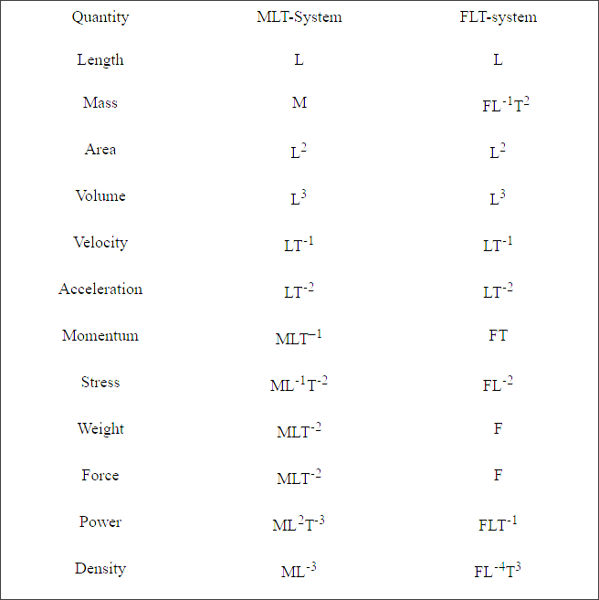

Fig. Dimensions of basic quantities in MLT and FLT systems

VECTORS:

Various quantities used in engineering mechanics may be grouped into scalars and vectors.
Scalar Quantity: A quantity is said to be scalar if it is completely defined by its magnitude alone. Examples of scalar quantities are:
Area, length, Mass, Moment of inertia, Energy, Power, Volume and Work etc.

Vector Quantity: A quantity is said to be vector if it is completely defined only when its magnitude as well as direction are specified. Examples of vector quantities include:
Force, Moment, Momentum, Displacement, Velocity and Acceleration.

Chapter 2 Force System

INTRODUCTION

Definition of ‘force’ can be given in several ways. Most simply it can be defined as ‘the cause of change in the state of motion of a particle or body’. It is of course, the product (multiplication) of mass of the particle and its acceleration.
Force is the manifestation of action of one particle on the other. It is a vector quantity.

CHARACTERISTICS OF A FORCE

A Force has following basic characteristics

- Magnitude

- Direction

- Point of application

- Line of action

Force is represented as a vector .i.e an arrow with its magnitude.

e.g. for the force shown in Fig., magnitude of force is 4KN, direction is 40° with the horizontal in fourth quadrant, point of application is C and line of action is AB.

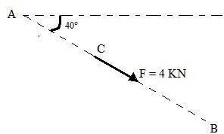

Fig. Characteristics of a force

Smaller magnitudes of forces are measured in newton (N) and larger in kilonewton (KN).

SYSTEMS OF FORCES

When a mechanics problem or system has more than one force acting, it is known as a ‘force system’ or ‘system of force’.

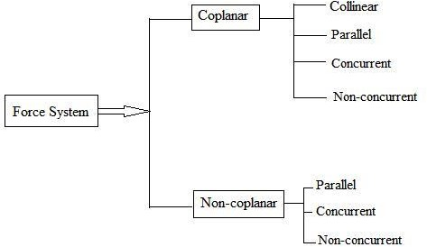

Fig. Force System

- Collinear Force System

When the lines of action of all the forces of a system act along the same line, this force system is called collinear force system.

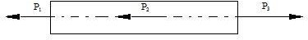

Fig. Force System

- Parallel Forces
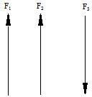

Fig. Force System

- Coplanar Force System

When the lines of action of a set of forces lie in a single plane is called coplanar force system.

Non-Coplanar Force System

When the line of action of all the forces do not lie in one plane, is called Non-coplanar force system

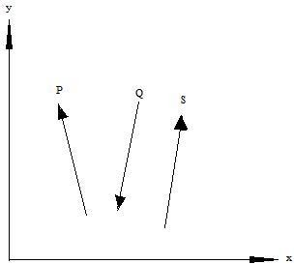

Fig. Force System

- Concurrent Force System

The forces when extended pass through a single point and the point is called point of concurrency. The lines of actions of all forces meet at the point of concurrency. Concurrent forces may or may not be coplanar.

Non-concurrent Force System

When the forces of a system do not meet at a common point of concurrency, this type of force system is called non-concurrent force system. Parallel forces are the example of this type of force system. Non-concurrent forces may be coplanar or non-coplanar.

Coplanar and concurrent force system

A force system in which all the forces lie in a single plane and meet at one point, For example, forces acting at a joint of a roof truss (see fig.2.6)
P = External force

F1 to F5 = Member forces (internal) RA and RB = Reactions

C = Point of concurrency
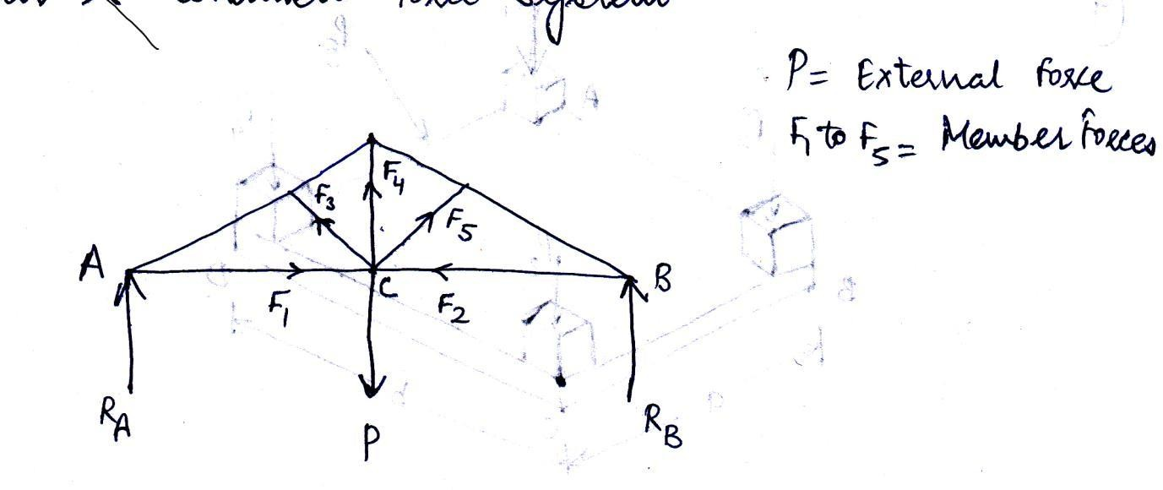

Fig. Coplanar concurrent force system Coplanar and non-concurrent force system
These forces do not meet at a common point; however, they lie in a single plane, for example, forces acting on a beam as shown in Fig.
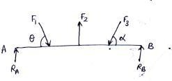

Fig. Coplanar non-concurrent force system Non-coplanar and concurrent force system
In this system, the forces lie in different planes but pass through a single point. Example is forces acting at the top end of an electrical pole (see Fig.)

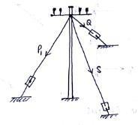

Fig. Force System Non-coplanar and non-concurrent force system
The forces which do not lie in a single plane and do not pass through a single point are known as non-coplanar and non-concurrent forces. Example is the loads transferred through columns to the rectangular mat foundation as shown in Fig.
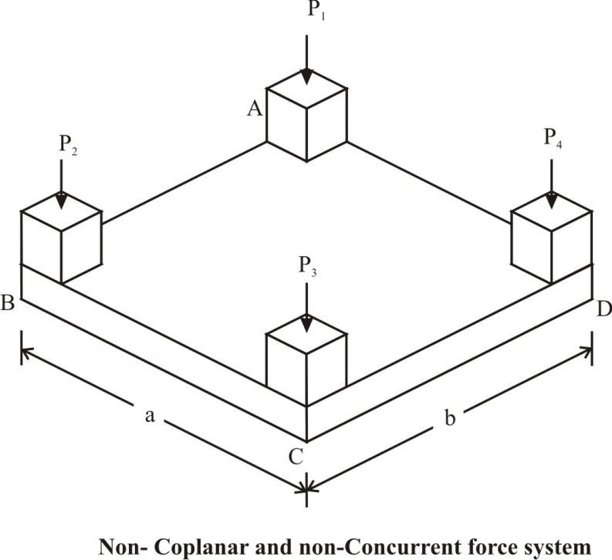

PRINCIPLE OF SUPERPOSITION OF FORCES

This principle states that the combined effect of force system acting on a particle or a rigid body is the sum of effects of individual forces.
Consider two forces P and Q acting at A on a boat as shown in Fig.3.1. Let R be the resultant of these two forces P and Q. According to Newton’s second law of motion, the boat will move in the direction of resultant force R with acceleration proportional to R. The same motion can be obtained when P and Q are applied simultaneously.
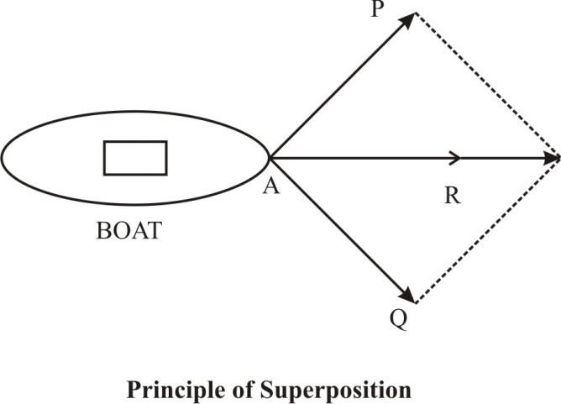

RESOLUTION OF A FORCE INTO COMPONENTS

A given force F can be resolved into (or replaced by) two forces, which together produces the same effects that of force F. These forces are called the components of the force F. This process of replacing a force into its components is known as resolution of a force into components. A force can be resolved into two components, which are either perpendicular to each other or inclined to each other. If the two components are perpendicular to one another, then they are known as rectangular

components and when the components are inclined to each other, they are called as inclined components. The resolution of force into components is illustrated as follows.

Resolution of a Force into Rectangular Components

Consider a force F acting on a particle O inclined at an angle Ө as shown in Fig. (a). Let x and y axes can be the two axes passing through O perpendicular to each other. These two axes are called rectangular axes or coordinate axes. They may be horizontal and vertical or inclined as shown in Fig. (b).
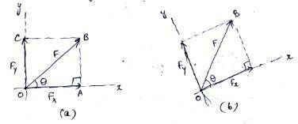

Fig. Resolution of force into rectangular components

The force F can now be resolved into two components Fx and Fy along the x and y axes and hence, the components are called rectangular components. Further, the polygon constructed with these two components as adjacent sides will form a rectangle OABC and, therefore, the components are known as rectangular components.
From the right angled triangle OAB, the trigonometrical functions can be used to resolve the force as follows:
cos Ө = OA \ OB

Therefore,

OA = OB × cos Ө

Or

Fx = OA = F cos Ө (4.1a)

sin Ө = AB\ OB

Therefore,

AB = OB × sin Ө

Fy = OC = AB = F sin Ө (4.1b)

Therefore, the two rectangular components of the force F are: Fx = F cos Ө and Fy = F sin Ө
The conventional coordinate directions are used for the sign conventions of the components of the force. That is, the components along the coordinate directions are considered as positive components and the one in the opposite direction as negative components. The sign conventions shown in Fig., are used in general.
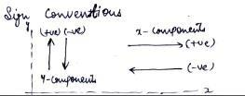

Fig. Sign conventions

RESOLUTION OF FORCE INTO INCLINED COMPONENTS

Sometimes, it is essential to know the components of a force, which are not perpendicular to one another. Such components are known as inclined components or non-rectangular components and they are determined either by triangular law of a force or by using law of parallelogram of forces.

Triangular Law of Forces

If two forces P and Q are acting on a particle A, then the two forces can be added or combined to form a single force F by arranging the forces in tip-to-tail fashion and then the single force is obtained by connecting the tail of the first force to the tip of the second force. Fig. (a) shows two forces acting on A. The two forces can be added either as shown in Fig. (b) or in Fig. (c). Considering the force Q as the first force acting at A, its tail end is at A and tip will be, say at B1. Now the tail end of force P is merged with the tip of force Q, that is at B1, and the force P is drawn. The tip of P will be at C (say). Therefore, the force F(addition of forces P and Q) is obtained by joining A (tail of Q) and C (tip of P). The same can also be achieved by considering the force P first and then Q as shown in Fig. (c). Since, the three forces P, Q and F from the three sides of a triangle, the law is therefore known as triangular law of forces. The single force F combining two forces P and Q is called resultant force.
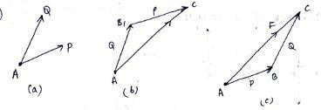

Fig. Triangular law of forces

The triangular law of forces is used for the addition of two forces. However, it can be extended to add more than two forces, which extend the law into polygonal law of forces. Fig.4.10 illustrates the addition of four forces P, Q, S and T. As shown in Fig. (b),F1, is the addition of forces P and Q. The resultant of forces P, Q and S is obtained by adding F1 and S as presented in Fig.4.10(c) in which triangular law of forces is applied to combine F1 and S. Similarly, F3 is the resultant of P, Q, S and T, which is an addition of F2 and T. It is pertinent to mention that the forces can be taken in any order.
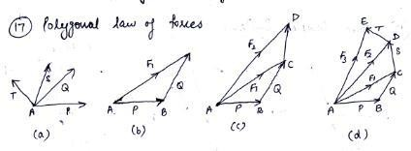

Fig. Polygonal law of forces

LAMI’S THEOREM

It states that,” If three forces acting at a point are in equilibrium each force will be proportional to the sine of the angle between the other two forces.”
Suppose the three forces P, Q and R are acting at a point O and they are in equilibrium as shown in Fig.

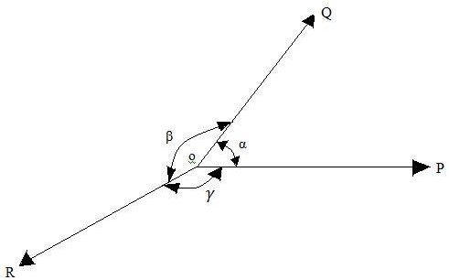

Let α = Angle between force P and Q. β = Angle between force Q and R. γ = Angle between force R and P.
Then according to Lami’s Theorem,

P α sine of angle between Q and R α sinβ. Therefore, P \ sinβ = constant
Similarly Q \ sin γ = constant and R \ sin α = constant Or
P \ sinβ= Q \ sin γ = R \ sin α= constant

FREE BODY DIAGRAM

A free body diagram is a sketch of a body, a portion of a body, or two or more bodies completely isolated or free from all other bodies, showing the forces exerted by all other bodies on the one being considered.Characteristics of free body diagram:-
  - It is a diagram or sketch of a body.
  - The body is shown completely separated from all other bodies.
  - The action on the body of each body removed in the isolating process is shown as a force or forces on the diagram.

EQUILIBRIUM OF FORCES

Equilibrium is defined as the condition of a body, which is subjected to a force system whose resultant force is equal to zero. It means the effect of the given force system is zero and the particle or rigid body is said to be in equilibrium.
For example, a particle subjected to two forces will be in equilibrium when the two forces are equal in magnitude, opposite in direction and act along the same line of action as shown in Figure.
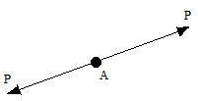

Fig. Equilibrium of forces

Equations of equilibrium for a concurrent, coplanar force system

The resultant of a concurrent, coplanar force system is a single force through the point of concurrence. When the resultant force is zero, the body on which the force system acts in equilibrium.
Consider the force system as shown in figure:

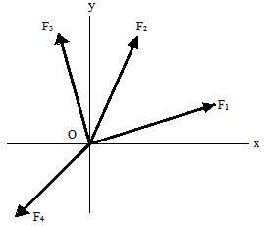

Fig. Equilibrium of concurrent and coplanar Force system

If the sum of the x components of the forces of the system is equal to zero, the resultant can act only along the y axis.
If in addition, the sum of the y components of the forces of the system is equal to zero, the resultant must be zero. Consequently, one complete set of equations of equilibrium for a concurrent, coplanar force system is
∑ Fx = 0, ∑ Fy = 0 (1)

Again, if the sum of the x components of the forces of the system is equal to zero, the resultant can be only a force along the y axis and if the sum of the moments of the forces of the system with respect to an axis through A is equal to zero where A is any

point not on they axis is not zero. Thus, another set of equations which assure equilibrium for this system is
∑ Fx = 0, ∑ MA = 0 (2)

Where A is not on the y axis.

In a similar manner, a third set of independent equations can be shown to be

∑ MA = 0, ∑ MB = 0 (3)

Where line AB does not pass through the point of concurrence of the forces of the system. There are only two independent equations of equilibrium for a concurrent, coplanar force system. When a force system of this type contains not more than two unknowns (two magnitudes, one magnitude and one slope, or two slopes), they can be determined directly from the equations of equilibrium.
When a concurrent, coplanar force system contains more than two unknowns, they cannot all be determined from the equations of equilibrium alone, and the force system is said to be statically indeterminate.
For a collinear force system, Eq.(1) reduces to one equation,

∑ Fx = 0

Where the x axis is parallel to the forces. Likewise, Eq.(2) can be reduced to the equation
∑ MA = 0

PRINCIPLE OR LAW OF TRANSMISSIBILITY OF FORCES: It
states that the state of rest or of Uniform motion of a rigid body is unaltered if the point of application of the force is Transmitted to any other point along the line of action of the force.”
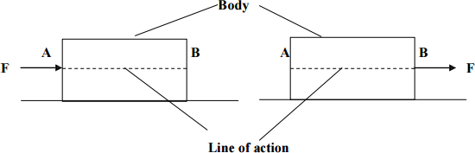

RESULTANT FORCE: Whenever a number of forces are acting on a body, it is possible to find a single force, which can produce the same effect as that produced by the given forces acting together. Such a single force is called as resultant force or resultant.
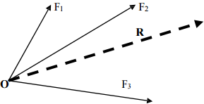

The process of determining the resultant force of a given force system is known as Composition of forces. The resultant force of a given force system can be determining by Graphical and Analytical methods. In analytical methods two different principles namely: Parallelogram law of forces and Method of Resolution of forces are adopted.

PARALLELOGRAM LAW OF FORCES:

This law is applicable to determine the resultant of two coplanar concurrent forces only. This law states ―If two forces acting at a point are represented both in magnitude and direction by the two adjacent sides of a parallelogram, then the resultant of the two forces is represented both in magnitude and direction by the diagonal of the parallelogram passing through the same point.”

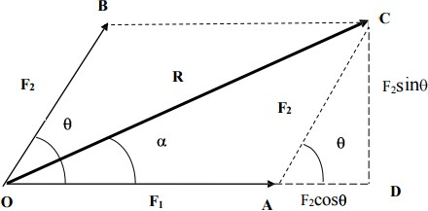

Let F1 and F2 be two forces acting at a point Oand be the angle between them. Let OA and OB represent forces F1 and F2 respectively both in magnitude and direction. The resultant R of F1 and F2 can be obtained by completing a parallelogram with OA and OB as the adjacent sides of the parallelogram. The diagonal OC of the parallelogram represents the resultant R both magnitude and direction.
From the figure

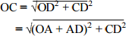
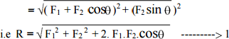

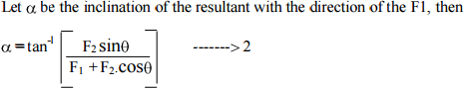

Chapter 3 MOMENT

MOMENT:
The moment of a force about the point O is the product of the force and the perpendicular distance to the line of action of the force from O.

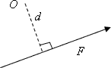
Moment =Fd

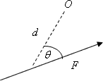
Moment =Fdsin

Clockwise moments are negative. Anti-clockwise moments are positive.
The resultant moment about O is the sum of the moments about O.

UNIT OF MOMENT: Nm

Moment = Force (N) x Distance (cm or m).

CONDITION FOR A BODY IN EQUILIBRIUM:

- The resultant force on the body must be zero.

and

- The resultant moment of the forces on the body about all points must be zero.

VARIGNON’S THEOREM

Varignon’s Theorem states that the moment of a force about any point is equal to the algebraic sum of the moments of its components about that point.

PRINCIPAL OF MOMENTS

Principal of moments states that the moment of the resultant of a number of forces about any point is equal to the algebraic sum of the moments of all the forces of the system about the same point.
LEVERS: A lever is a rigid rod that rotates around one point to move a load by applying a force to a third point.
TYPES :- there are two types of lever

  - Simple Lever
  - Compound Lever

Classes of Simple Levers

First Class Lever:- A first-class lever is a lever in which the fulcrum is located between the input effort and the output load.
In operation, a force is applied (by pulling or pushing) to a section of the bar, which causes the lever to swing about the fulcrum, overcoming the resistance force on the opposite side.

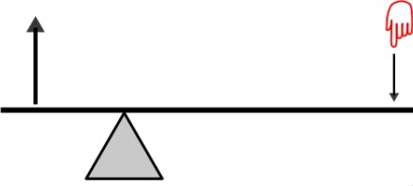

Examples:

  - Seesa
  - Scissors (double lever)

Fulcrum is between FE (effort force) and FL (load force) When the effort moves farther than load, the Mechanical advantage >1 When the effort moves less than the load, the Mechanical Advantage < 1

Second Class Lever

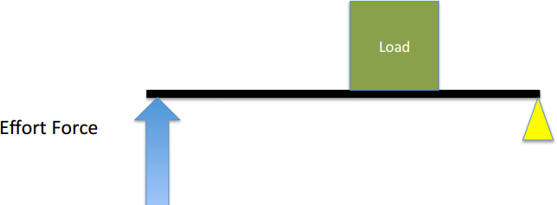

Load is between fulcrum and Effort, Effort moves farther than Load. Multiplies Effort Force, but does not change its direction the mechanical advantage of a 2nd class lever is always greater than 1
Examples of second class levers:

  - nut crackers
  - wheel barrows
  - doors
  - bottle openers.

Third Class Lever

Effort is between fulcrum and Load. Does not multiply force Load moves farther than Effort. Multiplies the distance the effort force travels and the speed at which it moves.

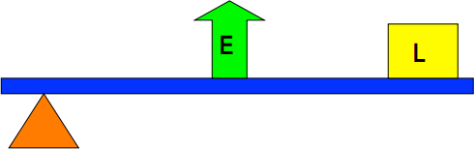

The mechanical advantage of a 3rd class lever is always less than 1. Examples:
  - Hockey Stick
  - Tweezers
  - Fishing Rod

COMPOUND LEVER

The compound lever is a simple machine operating on the premise that the resistance from one lever in a system of levers will act as power for the next, and thus the applied

force will be amplified from one lever to the next (as long as the mechanical advantage for each lever is greater than one)
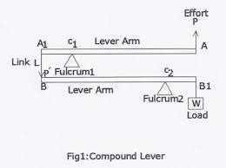

COUPLE

A system of two equal parallel forces acting in opposite directions is said to form a couple. Fig. shows a couple formed by horizontal, vertical and inclined forces.
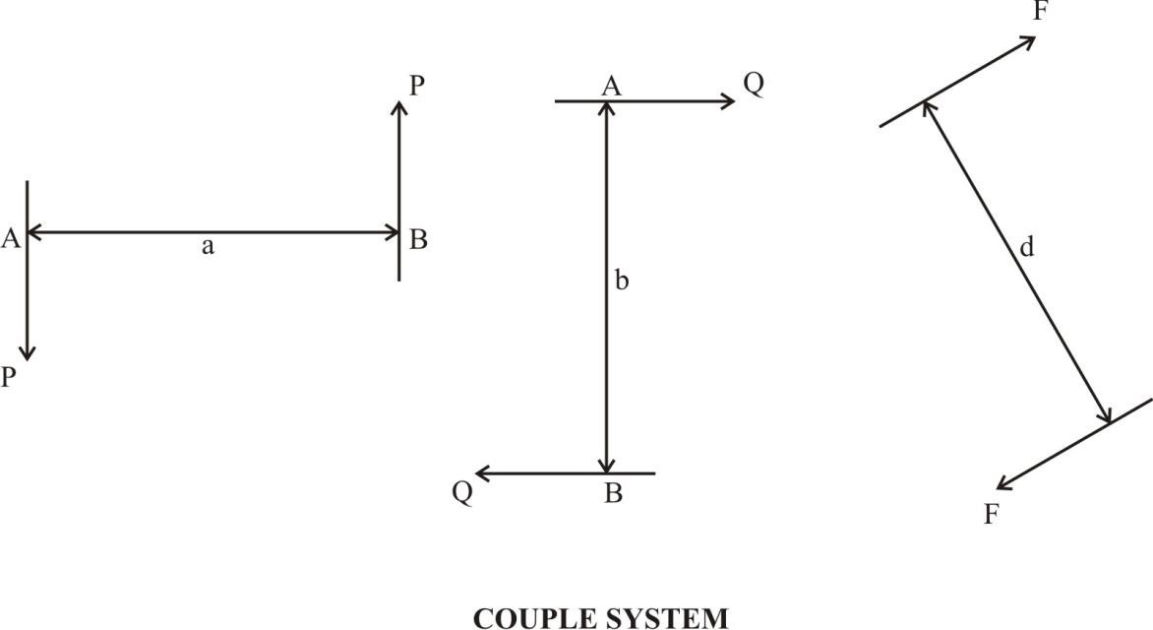

The plane in which the two forces forming a couple lie is called the plane of the couple and the distance between their line of action is called the arm of the couple. Any couple acting on a rigid body produces only rotation to the body. This rotation is measured by the moment of the couple, which is product of magnitude of the force and the distance between the two forces (arm of the couple). In contrast, the couple does not cause any translation to the rigid body.
The magnitude of the moment of the couple is determined by using the principle of superposition. That is, the moment of the couple is equal to the sum of the moment of the two forces of the couple about any point. As seen in Fig.3.3, the moment of couple about O1 is given by
MO1 = +F(d1) – F(a+d1) = -F × a (2.1a)

Similarly, the moment of the couple about point O2 is

MO2 = -F(a-d2) – F(d2) = -F × a (2.1b)
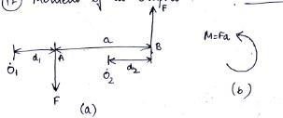

Fig. Moment of a couple

It is clear that the moment of a couple about any point is always constant. Interestingly, couple can also be diagrammatically shown by a rotation arrow as shown in Fig. indicating the magnitude of the moment of a couple, M = Fa.

CHARACTERISTICS OF A COUPLE

A couple is completely defined by following elements:

- The magnitude of its moment

- The plane in which it acts defined by the direction of the normal to the plane.

- The direction of rotation in the plane that is the sense of the couple.

Moment of a couple is a vector quantity having the direction normal to the plane in which it acts.

