GOVT. POLYTECHNIC. DHANGAR

Branch: Mechanical Engineering Semester: 3rd
Subject: Materials and Metallurgy Chapter 1: Introduction
Chapter 3: Metallurgy
Chapter 6: Plastics

Chapter 1
Introduction

Material
- Material is made of matter.
- Material is that form which something is made or can be made.
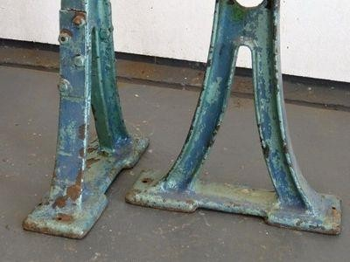
- Example: Cast iron, plastic, ceramics etc.

Engineering material
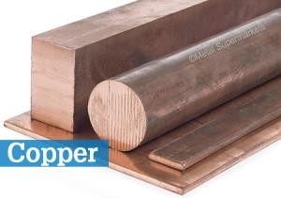
- Solid materials used in the various fields of engineering to serve various demand and applications.
- Example: Cast iron, copper, aluminum etc.

History and timeline of material
origin

Stone age:
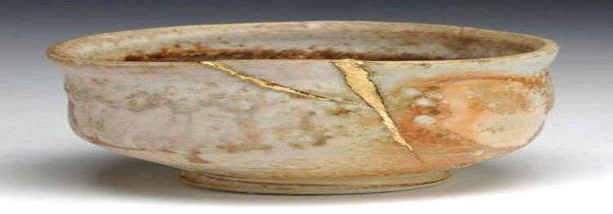
- Around 6000BC, used for making the clay bowls.

Copper age:
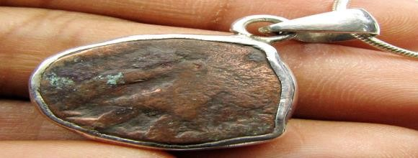
- In 8000 BC , used in Mesopotamia (Iraq) for making tools, containers and ornaments.

History and timeline of material
origin

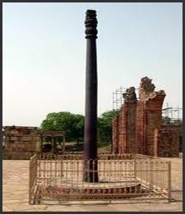
Iron age:
- In 1500 BC ,first used in Asia-Minor in Turkey.

Modern age (Iron-plastic age):
- Advanced materials modified such as Nano-materials.
- Use low cost and high qualities materials such as plastic and fibres.
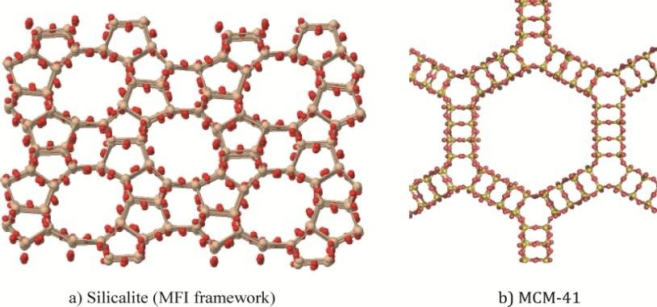

Scope of material science
- Investigation of relationship between the structure of materials and their properties.
- Human civilization and social development.
- Vast scope in different fields of engineering:
- Mechanical engineers need material of higher temperature for efficient operation of gas turbine.
- Electrical engineers search for a material which has minimum power loss
for electrical devices.
- Electronics engineers search material such as semiconductor, nanomaterials etc.
- Civil engineers search having high strength
- Aerospace engineers manufacturing of strong aero vehicle
- Chemical engineers high corrosive resistant property.

Overview of different engineering
materials and application

Metal and alloys
- Can easily give up or loose electrons to form metallic bond.
- Good thermal and electrical conductivity.
- Example: Cast iron, copper etc.
- Mixture of two more metal kwon as alloys.
- Example: Brass, bronze etc.
- Use : Railways bridges, surgical instruments, cutting tools etc.

Types of metals
- Ferrous metal: Contain iron element.
- Non- ferrous metal: Not contain iron element.

- Non metals
- Tendency to gain two or more electron.
- Good thermal and electrical insulators.
- Example: Plastic , wood, Bakelite, rubber etc.
- Use: Electrical insulation, tiles, utensil, paints etc.

Ceramics
- Inorganic, non-metallic materials made from compounds of a metal and a non metal.
- Good work at high temperature.
- Example: Glass, clay, nitride etc.
- Use : Aerospace engineering, glass and chemical engineering.

Polymers
- Chemical reaction bonding monomers together to make a polymer is called polymerization.
- Example: Nylon, polyethylene, polyester, Teflon etc.
- Use: Agriculture, automobiles, adhesives, packing and helmet manufacturing,

Composites
- Manufactured by combining of more than one different material.
- Example: Fiber glass, RCC etc.
- Use: Aircraft structure and electrical transmission towers.

Semiconductors
- Having electrical conductivity between conductors and insulators.
- Intrinsic semiconductors
- Absolutely pure state , do not doped with impurities
- Extrinsic semiconductors
- Doped with impurities
- n-type semiconductors: contain excess free electrons.
- p-type semiconductors contain excess holes.
- Example: Silicon, Germanium, Gallium Arsenide, Cadmium
Sulphide.
- Use: Solar panel, led, electronic components.

- Biomaterials
- A biological or synthetic substance which can be introduced into body tissue as part of an implanted medical device or used to replace an organ, bodily function, etc.

- Example: Nylon, silicon, stainless steel, aluminum oxide, carbon wire.

- Use: Heart valve, joint replacement, soft tissues, orthopedic implants, dental coating and contact lens etc.

Classification of materials

Materials
Metals Metalloids Non-metals

Ferrous metals
Non-ferrous metals
Ceramics Polymers Composites Semi
conductors
Others

Metals Alloys Metals Alloys

S.NO | Property | Metals | Non-Metals
1. | Lustre | Lustrous | Non lustrous. Exception are iodine and graphite.
2. | Physical  state | Solid at room temperature.  Exception is mercury. | Solid, liquid or gas at room  temperature.
3. | Density | Higher densities. Exception alkali metals like lithium. | Lower densities. Exception is iodine.
4. | Hardness | Generally hard. Exception is lead. | Hardness varies from soft to very hard. Exception is diamond which is hardest.
5. | Malleability and ductility | Generally malleable and ductile. Exception is bismuth is brittle. | Generally brittle.
6. | Strength | Generally stronger. | Have lesser strength.
7. | Conductivity | Possess good. Exception lead and bismuth. | Bad conductors. Exception graphite.

S.  NO. | Property | Metals | Non-metals
8. | Nature  of oxides | Basic | Acidic
9. | Formatio n of bond | Metallic bond. | Ionic or covalent bond.
10. | Melting point | Generally high. Exception are potassium and sodium. | Generally low. Exception is carbon.

Physical properties of material
- Describe a material under conditions free from external forces.

- Appearance : Different materials look differently. A metal looks clearly distinct
from plastic or wood.

- Lustre: Ability of the surface of a material to reflect light when finely polished.

- Colour : Depends upon the wavelength of the light that material can absorb. Metal like Al is white colour and Copper is brownish red.

- Density: Mass per unit volume of a material. Metal have higher density than non metals.

- Melting points: Temperature at which material changes from solid state to liquid state.

Mechanical properties of material
- Describe its behavior under the action of applied external forces.
- Elasticity: Elasticity is the ability of the material to regain its original form when the external force is removed. Steel's elasticity is greater than rubber.
- Plasticity: The ability of the material to deform permanently. It helps to shape the material to make into thin plates or molds.
- Strength: The ability of the material to resist external forces. Without Yielding (Yield point is the point at which plastic deformation starts) breaking.
- Stiffness: The ability of the material to resist deformation when stress is applied. This is measured by the modulus of elasticity.
•

Mechanical properties of a material

- Ductility: Ductility is the property of the material which makes it enable to become thin wire with the application of tensile force (equally intense pull). The mechanical properties of mild steel show that it is very ductile.
- Brittleness: Brittleness refers to the property of the material due to which a material breaks with association of very little distortion. Brittle materials are glass, ceramic, cast iron.
- Malleability: Ability of material to be formed in the form of a thin sheet by hammering or rolling. Lead, soft steel, copper etc are very much malleable which are used in the engineering process.
- Toughness: It is the ability of the material to prevent fracture when high impact load and shocks are applied. Toughness is reduced when
the material is heated.

material
- Creep: The phenomenon of permanent and slow deformation of the material when subjected to constant stress at high temperatures. IC engines, boilers etc. are designed keeping this term in head.

- Fatigue: When material is subjected to repeated loads, it fails before reaching the yield point. This type of failure is called fatigue. At first cracks developed in the machine parts in microscopic level and with time the probability of failure increases.

- Hardness: To resist scratching, abrasion, surface wear or indentation by harder bodies.

materials
- Nuclear energy holds some promise, but the solution to the many key problem that remain will, necessarily, involve materials from fuels to containment structures to facilities for the disposal of radioactive waste.

- New high strength, low density structural materials remain to be developed, as well as materials that have higher temperature capabilities, for use in engine components.

- Hydrogen seem to be the fuel of the future.

- Need to improve material processing and refinement methods.

Various issue of material usage
- Economic issue

- Environmental issue

- Social issue

- Recycling issues

Chapter - 3
Metallurgy

Metallurgy
- Science of extracting metals from their ores and modifying the metals for use.

Cooling curve of pure metal:
- A cooling curve is a line graph that represents the change of phase of matter, typically from a gas to a solid or a liquid to a solid. The independent variable (X-axis) is time and the dependent variable (Y-axis) is temperature.
- Cooling curve for the solidification of a pure metal under equilibrium conditions, all metals exhibit a definite melting or freezing point.
- If a cooling curve is plotted for a pure metal. It will show a horizontal line
at the melting or freezing temperature.

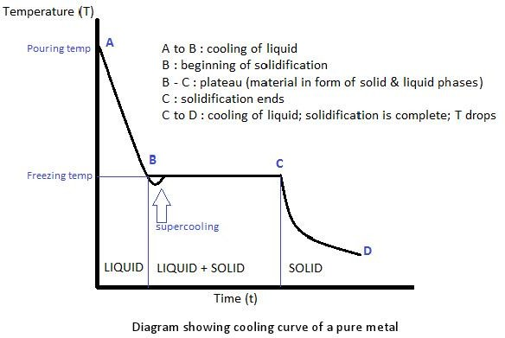

- If slow fall in temperature results in the formation of a few nuclei around which crystal grow unrestricted to large size.

- Solidified metal has coarse grains.

- If temperature of molten metal falls rapidly or sufficient nuclei do not form, the molten metal faces a considerable difficulty in starting crystallization and under cooling (Sub cooling) may take place.

- Molten metal cool below its real freezing point.

- Solidified metal has fine grains.

metal
- A dendrite in metallurgy is a characteristic tree-like structure of crystals growing as molten metal freezes, the shape produced by faster growth along energetically favorable crystallographic directions.
- Dendritic growth has large consequences in regard to material properties.
- Generally dendrite structure formation takes place when a cast metal cooling rate is very high and it occurs in non-equilibrium cooling.

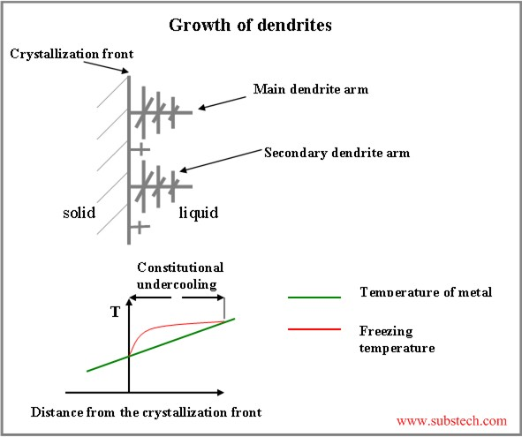

properties

S. NO. | Property | Fine grain metal | Coarse grain metal
1. | Strength | More | Less
2. | Toughness | More | Less
3. | Hardness | More | Less
4. | Ductility | More | Less
5. | Creep resistance | Less | More
6. | Machinability | Less | More
7. | Machining finish | Smoother | Less smooth

- Pure metal freezes at a definite and constant temperature.
- Alloys freezes over range of temperature except eutectic composition.
- A and B point are known as arrest points.

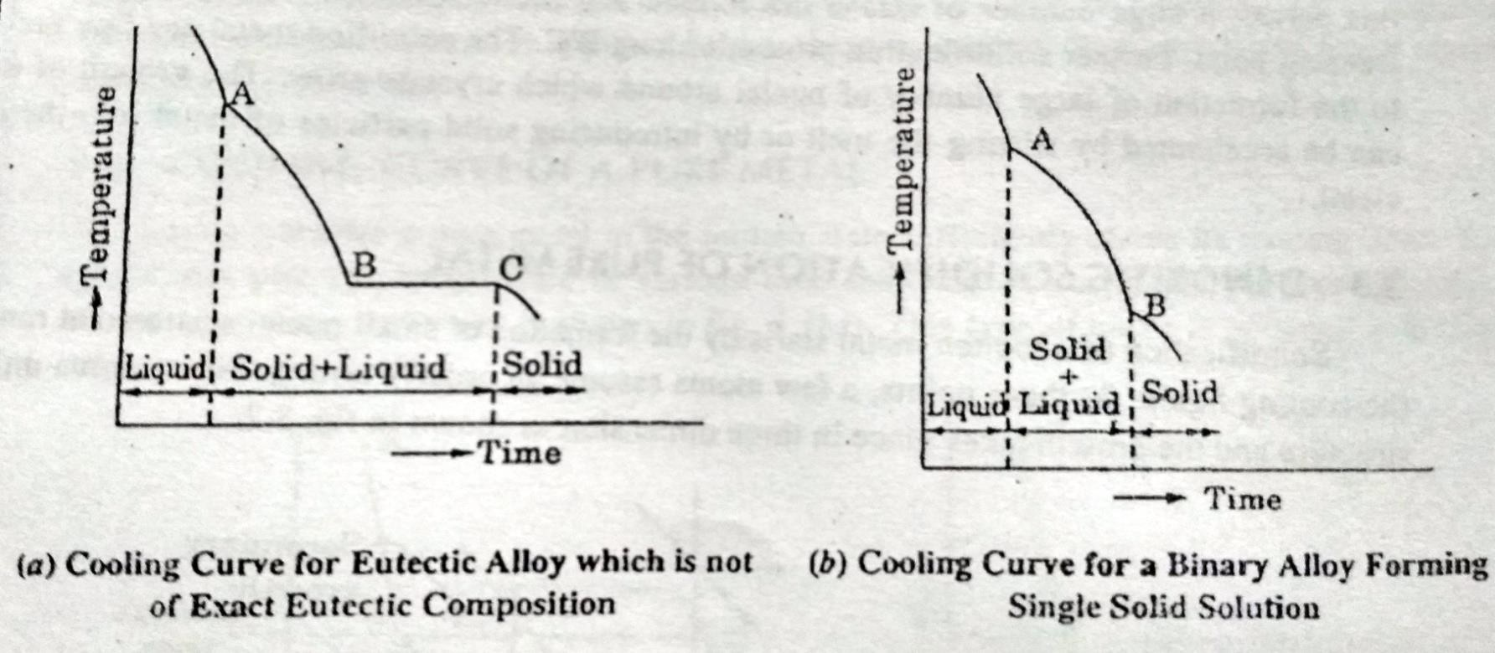

- Indicates the structural changes take place heating and cooling of an alloy series.
- It also known as phase diagram or constitutional diagram and temperature
composition diagram.
- Contain special information about changes that take place in alloys during cooling.
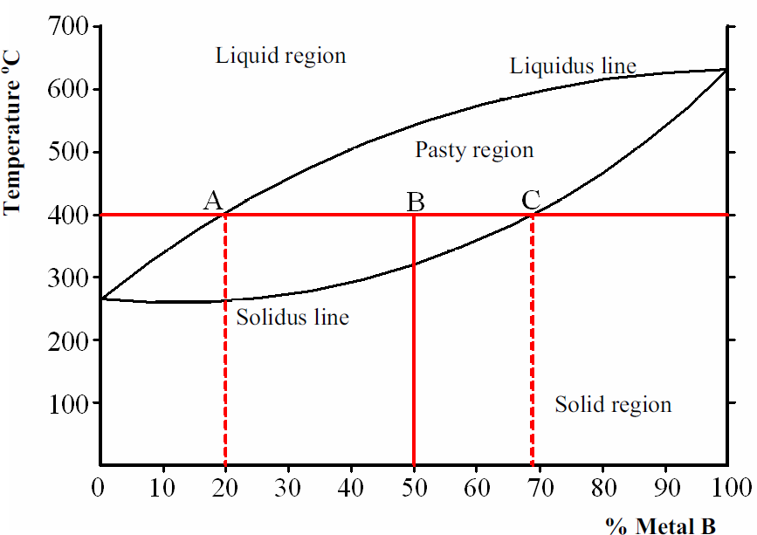

- Series of Cooling curves at different metal composition are first constructed.
- Point of change of slop of cooling curves (thermal arrest) noted and phase
diagram is constructed.
- The greater the number of cooling curves the more accurate the phase diagram.
- Eutectic meaning ease to melting.
- At (40% A and 60% B) is eutectic temperature, both metal A and B will solidify simultaneously at constant temperature.

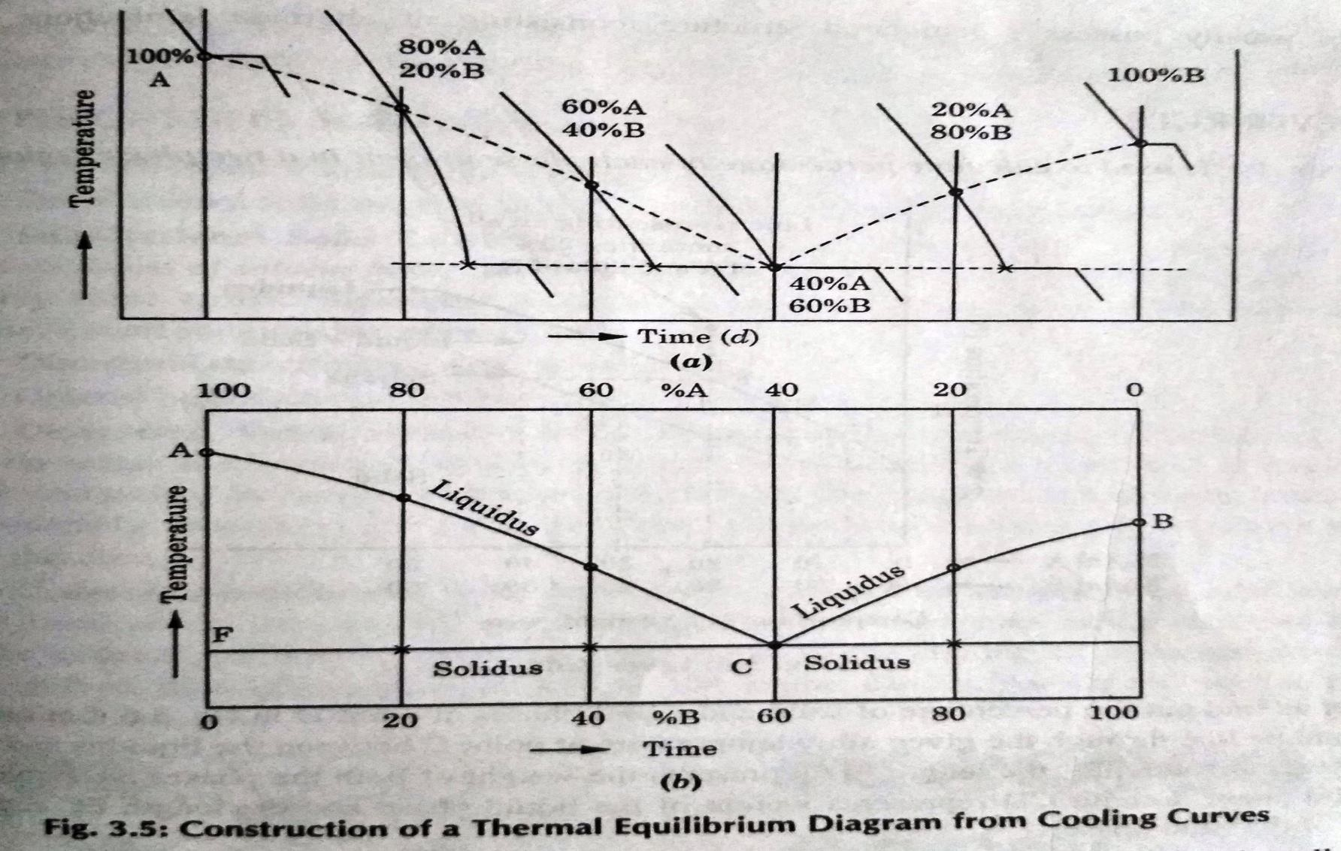

- Used to calculate percentage of each phase present in a two phase region.

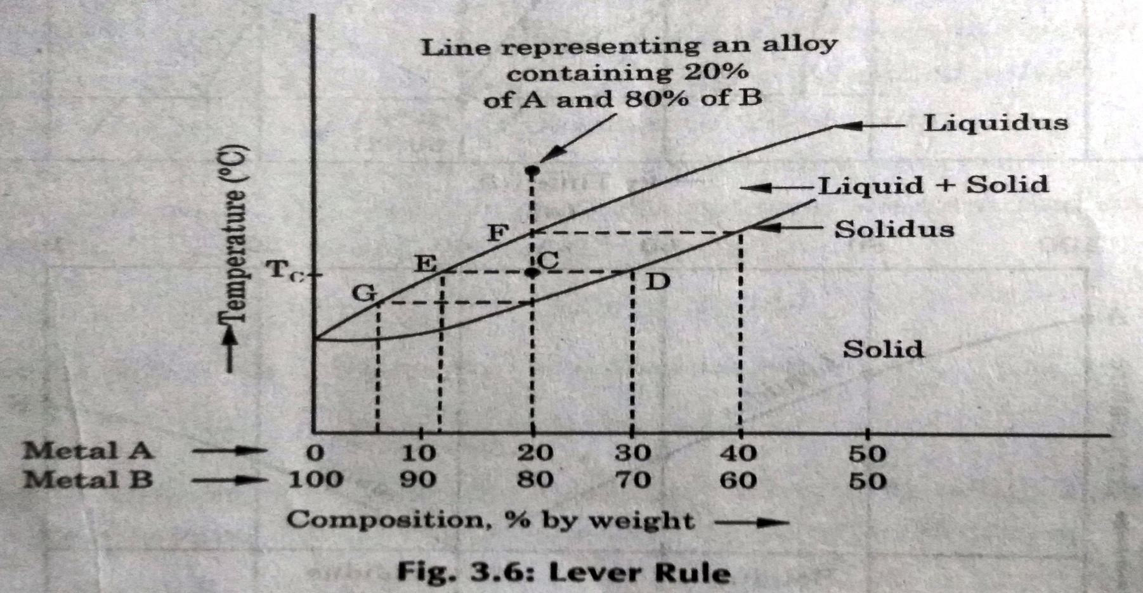

- It is used to determine the percent of liquid and solid phases for a given binary composition and temperature that is between the liquidus and solidus line.
- Length CD represents weight of liquid phase.
- Length EC represents weight of solid phase.

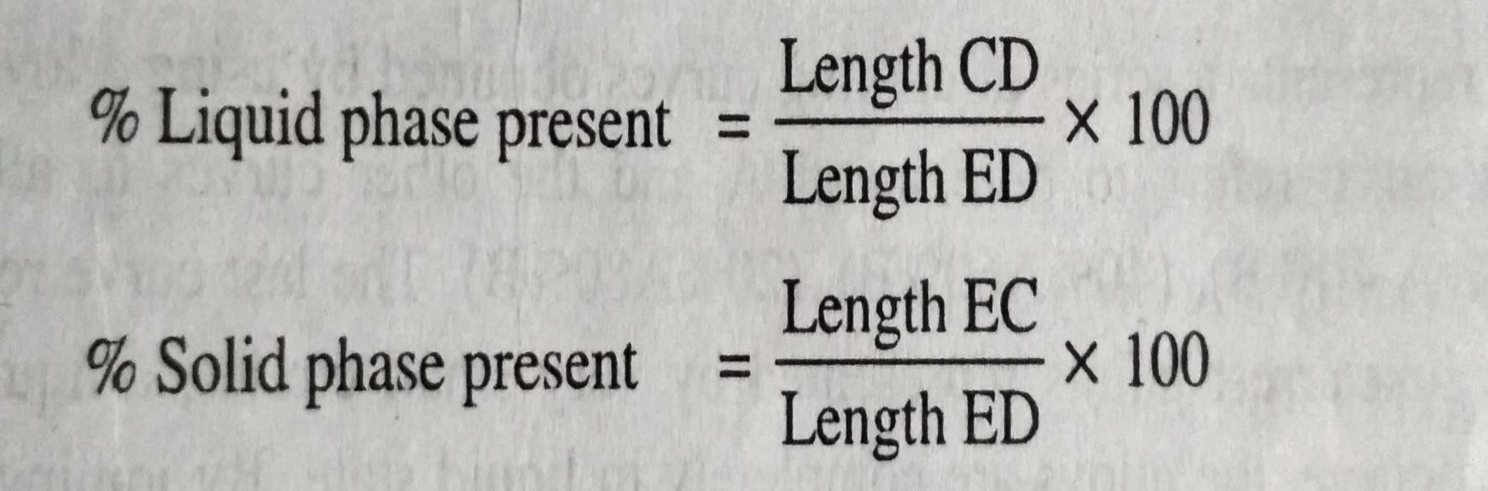

Eutectic (Binary)

- Liquid
Cooling

Heating

Solid1+Solid2

- Solid1 Solid1+Solid2

Liquid

Peritectic (Binary)
- Delta + Liquid = Austenite

Solid1

Solid2

Solid2

- Peritectoid (Binary)
- Cementite + ledeburite = Cast iron

Solid1

Solid3

- Both metals are completely soluble in one another.
- One type of crystal is formed.
- Under a microscope, looks like a pure metal.
- Usually stronger and harder, poorer electrical conductivity but not as elastic.
- Example: Au-Ag, Au-Pt and Cu-Ni etc.

Substitutional Solid Solution
- Atoms of both metals are of similar size.
- Direct substitution takes place.
- Substitution normally at random.
- If ordered, it is called a Superlattice.
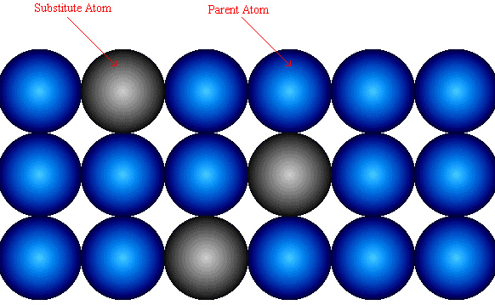
•

Interstitial Solid Solution Alloys
- Parent metal atoms are bigger than atoms of alloying metal.
- Smaller atoms fit into spaces, (Interstices), between larger atoms.
- If ordered, as below, it is again called a Superlattice.
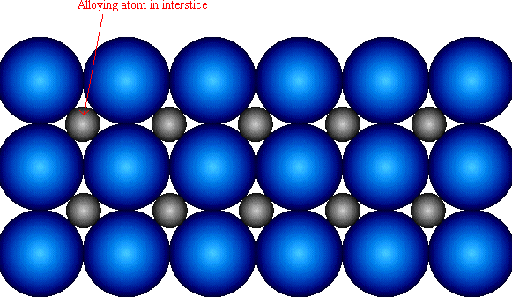

Chapter - 6
Plastics

Plastics
- Plastics:
- A synthetic material made from a wide range of organic polymers such as polyethylene, PVC, nylon, etc., that can be moulded into shape while soft, and then set into a rigid or slightly elastic form.

Importance of plastics:
- The versatility of plastic materials comes from the ability to mold, laminate or shape them, and to tailor them physically and chemically. There is a plastic suitable for almost any application.
- Plastics do not corrode, though they can degrade in UV (a component of sunlight) and can be affected by solvents — for example, PVC plastic is soluble in acetone.

This material is man made and is a by product of the oil industry.
- There are two types of plastic :
- Thermoplastics
- Thermosetting

- These are described as plastics that can be reformed using heat : this plastic has a memory, it returns to its original flat shape when re-heated.
- Examples and their uses :
- Acrylic – available in almost any colour in sheet rod or tube form, can be shaped using a line bender or vacuum former.
- ABS – a very commonly used plastic can be injection moulded from a powder form.
- 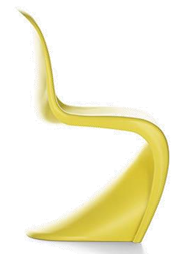Styrene – very good for vacuum forming.
Poly

propylene

ABS.

- These are described as plastics that do not reform using heat, they “SET” and cannot be reshaped.

Examples and their uses:
- Urea formaldehyde – electric plugs and sockets.

Melamine – kitchen worktops, unbreakable drink mugs.

- Polyester resin – poured into moulds to make products or for boat repair.

Thermoplastics materials:
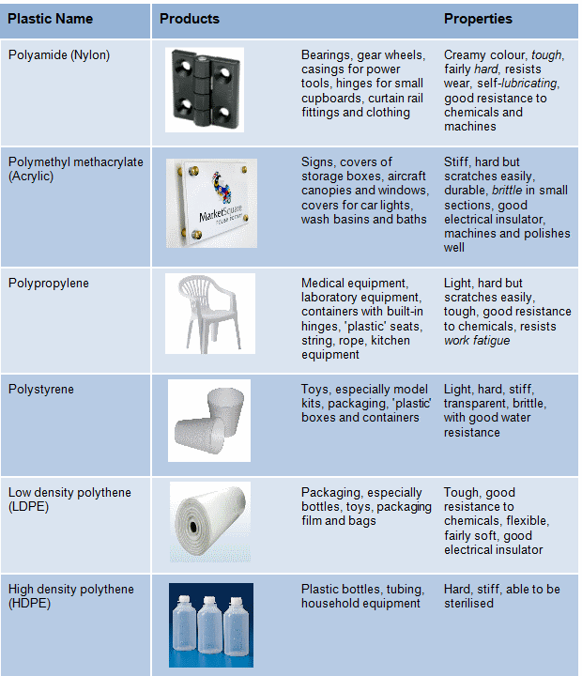

- Thermosetting plastics:
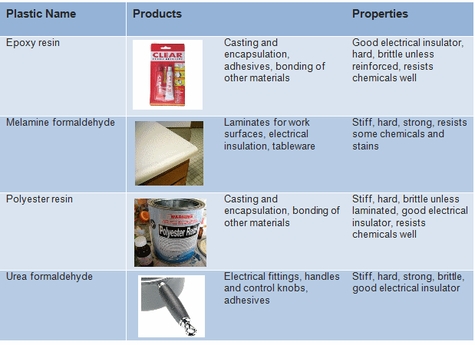

- To provide a layer of plastics on any surface of metal.
- The powder may be a thermoplastic or a thermo set polymer.
- It is usually used to create a hard finish that is tougher than conventional paint.
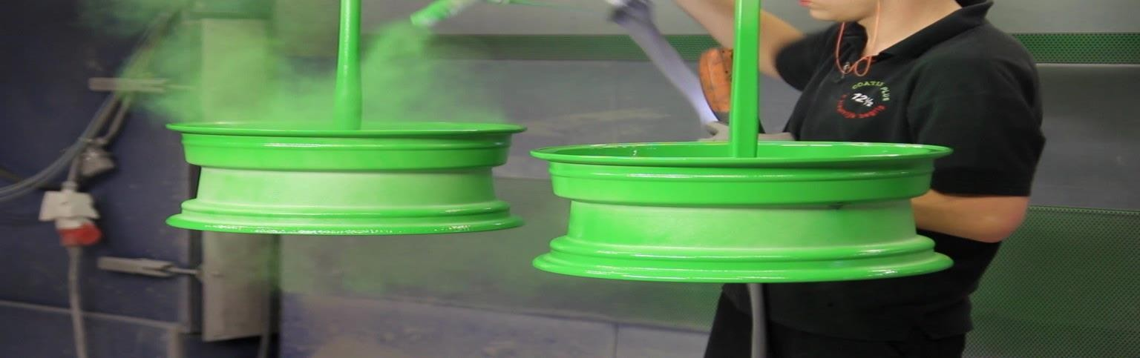
- Powder coating is mainly used for coating of metals, such as household appliances, aluminum extrusions, drum hardware and automobile and bicycle parts.

Dip Coating:
- The dipping of metal components into Thermoplastic powders or, Fluidized Bed dipping, as it is sometimes known, is the oldest form of plastic coating.

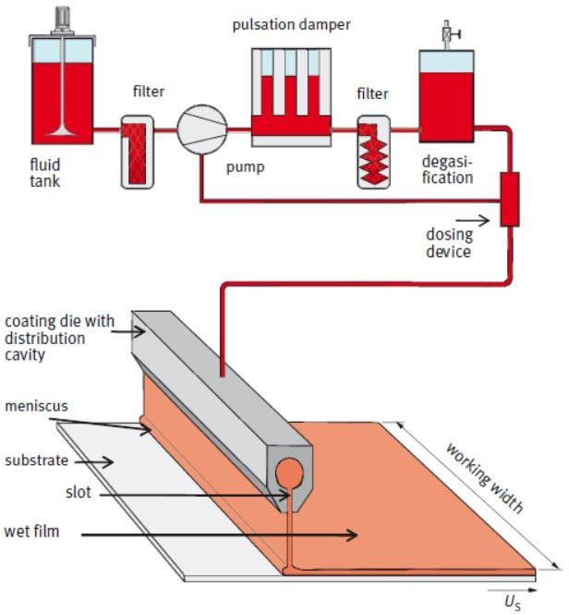

Electrostatic spraying :
- In the electrostatic spraying process, the powder to be used as coating is fluidized using air. This fluidized powder is supplied to the spray gun through a small hose.
- The nozzle of the spray gun uses high-voltage DC power to charge the fluidized powder particles and deposit them on the substrate.

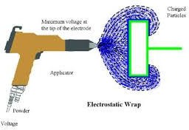

Vacuum coatings:
- Vacuum coatings allow the deposition of both elemental and compound materials of interest, and also enable coatings to be deposited upon a large range of materials, including non-electrically conducting materials such as plastic, fiber and wood.
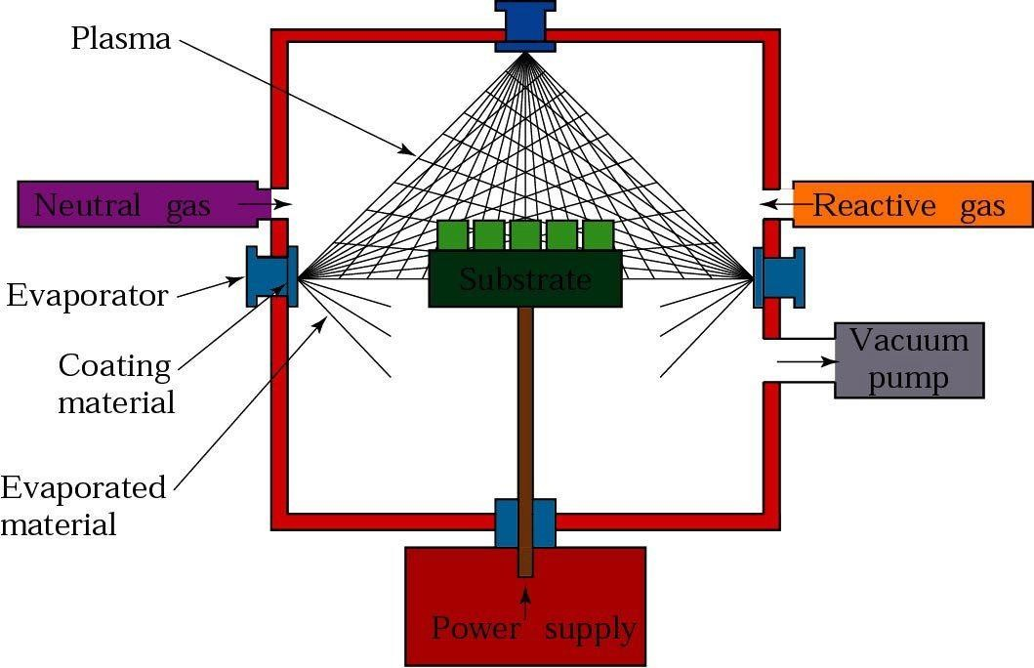

- Food grade plastics has certain standards of purity. It is free from dyes and other additives which are harmful to human health.

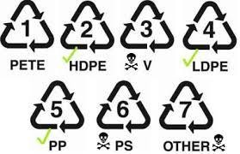

Application of plastics in
automobile

S. NO. | PLASTICS | USE
1. | Polypropylene (PP) | Automobile bumper, chemical tank, gas can.
2. | Polyurethane (PUR) | Flexible foam seating, elastomeric wheel and tyers.
3. | Polyvinyl chloride (PVC) | Automobile instrumental panels, sheathing of electrical cables.
4. | Acrylonitrile butadiene  styrene (ABS) | Automobile body parts, dashboards, wheel  covers.
5. | Polystyrene (PS) | Equipment housings, buttons, car fittings, display bases.

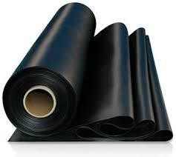
Rubber
- A tough elastic polymeric substance made from the latex of a tropical plant or synthetically.
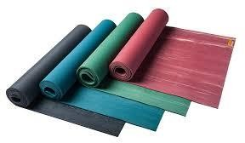
- 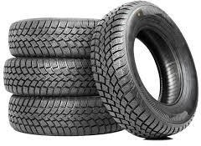It is used for making tyres, boots, and other products.

Natural rubber:
- The elastic material which is obtained from the latex sap of trees is called natural rubber.
- The rubber molecules present in these latex tubes are made up of 5 carbon and 8 hydrogen atoms.
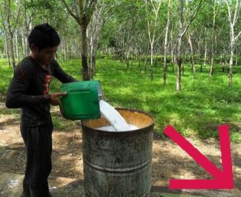
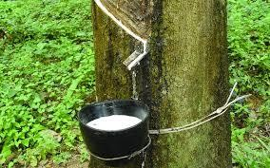
- A large number of these rubber molecules are joined with each other to form long, chain-like structure. This chain of rubber molecules is called polymers that gives rubber its property of elasticity

Synthetic Rubber:
- Any kind of artificial elastomer (a polymer) is called synthetic rubber. Thus, the type of rubber made from chemicals to act as the substitute for natural rubber is the synthetic rubber.

Vulcanized Rubber:
- Vulcanized rubber, though made from natural rubber, is sometimes taken to be a separate kind of rubber. Natural rubber, in its original form, is not suitable for industrial or commercial purposes.
- In fact, natural rubber has many such properties that decreases its usability as commercial rubber type.
- The process of vulcanization is used to improve the properties of natural
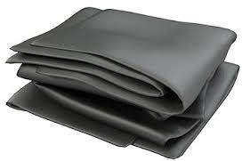
rubber and to convert it into a useful industrial rubber type.

It depends upon following points:
- Mechanical properties
- Thermal properties
- Electrical properties
- Environmental properties
- Cost

