GOVT. POLYTECHNIC. DHANGAR

Branch: Mechanical Engineering Semester: 3rd
Subject: Mechanical Engineering Drawing
Chapter 1: Limit, fits and tolerance Chapter 2: Couplings, Bearings, Pulleys,
Pipe Joints and Lathe Tool Holder Chapter 3: Drilling Jig

Chapter 1
Limit, fits and tolerance

Need of limits, fit and tolerances

For mass production and specialization.
- Standardization.
- Interchangeability.

- Dimensional tolerances
- The difference between maximum and minimum limits.
- The system in which deviations are accepted is called limit system.

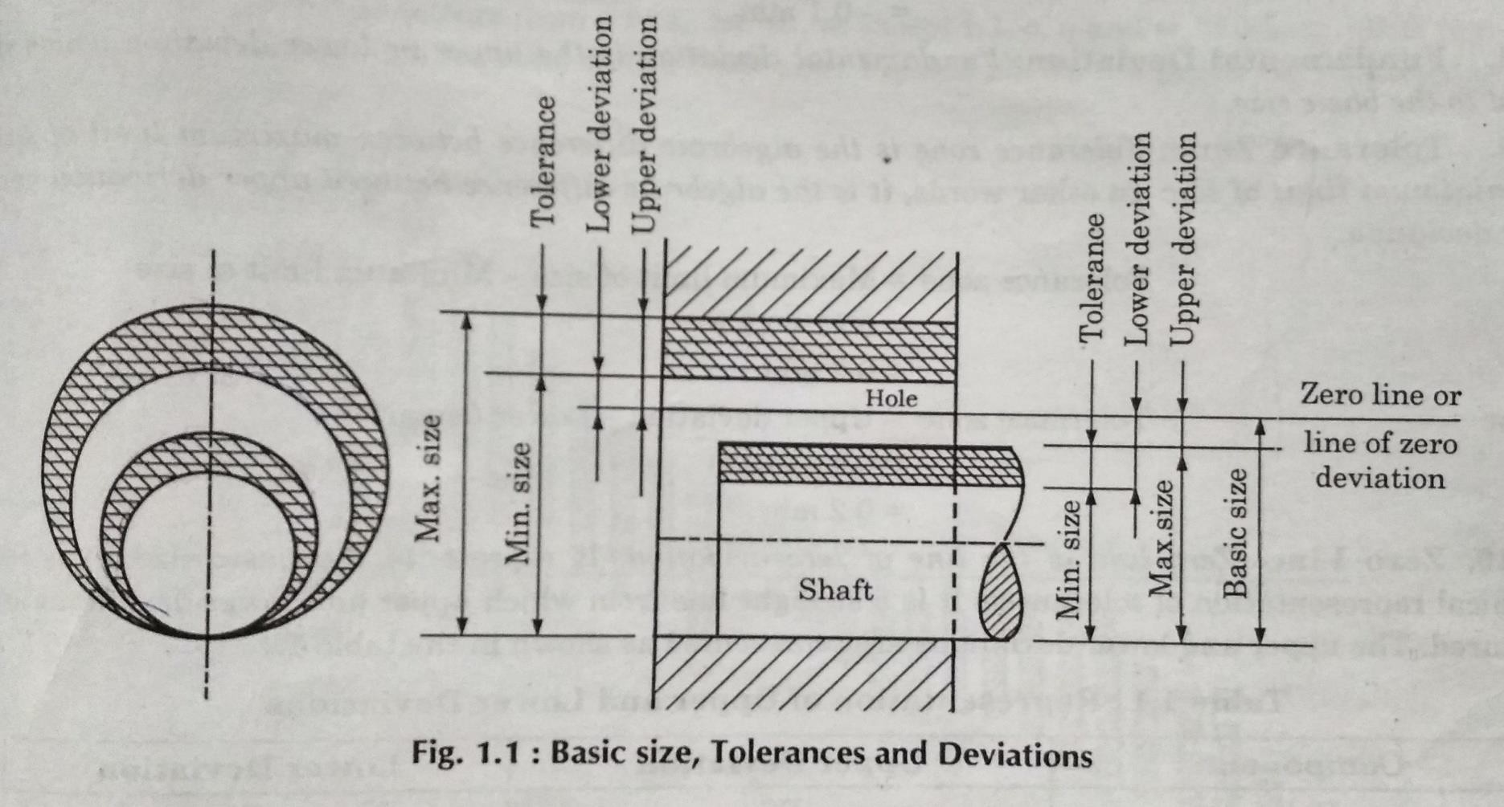

- Basic size:
- The nominal diameter of the shaft (or bolt) and the hole. This is, in general, the same for both components.
- Deviation:
- The algebraic difference between the actual measured size and the corresponding basic size.
- Lower deviation:
- The difference between the minimum possible component size and the basic size .
- Upper deviation:
- The difference between the maximum possible component size and the
basic size.

Fundamental deviation:
- The minimum difference in size between a component and the basic size. This is identical to the upper deviation for shafts and the lower deviation for holes.

- Upper or lower deviation which is closest to the basic size.
- Fundamental deviation is a form of allowance rather than tolerance.

Tolerance zone:
- The algebraic difference between upper deviation and lower deviation.

Zero line:
- Zero line is the line of zero deviation.

Limits:
- It is the highest and lower parameters of a component/object.

Unilateral limits:
- Both the limits of size are on the same side of zero line.

Bilateral limits:
- One of the limits of size is one side of zero line while the other is on the other side.

Allowance:
- The difference between the dimensions of two mating parts is called allowance.
- Allowance is the difference between the max. material hole and shaft
either it is max. interference or min. clearance.

Basic hole:
- Hole whose lower deviation is zero.

Basic shaft:

Shaft whose upper deviation is zero.

- Design size:
- It is the size on which the design of individual feature is based and so the size which should be specified on the drawing.
- When there is no allowance ,it is identical as basic size.

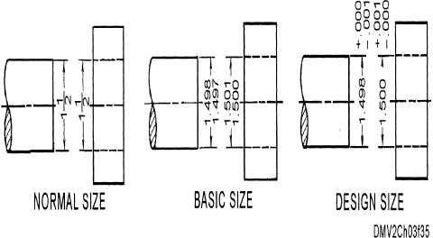

- Fits:
- When two mating parts are to be assembled is called Fits.

Clearance Fits:
- This is the difference between the size of the Hole and Shaft before Assembly.
- This difference is Positive.
- These are loose fittings.

Interference Fits:
- There is always a negative allowance between the Largest size and smallest shaft size .e.g. Driving fit or force fit.
- The shaft size is always larger than the Hole. 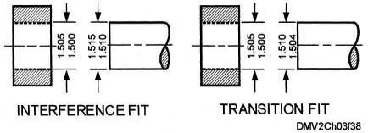
- Transition Fits:
- It is the fit which may provided either a clearance or a interference.
- These are categorized into
- Force fit e.g. Railway fit, Tram card.
- Running fit e.g. shaft is rotating in bearing.
- Push fit.
- Driving fit. e.g. pulley fitted on a shaft with key.

Shaft basis system:
- The design size of the shaft and the allowance is applied to hole i.e. the shaft size kept constant.
The design size of the hole is obtained by adding the allowances to the base size of the shaft. The lateral symbol is h.

Hole basis system:
- It is the system of fit in which design size of the hole is the basic size and allowance is applied to the shaft i.e. the size of the hole remains constant.
- The design size obtained by the subtracting allowance from the basic size of the Hole. The lateral symbol is H.

- Clearance:
- The difference between the dimensions of the hole and the shaft assigned intentionally to obtain a particular type of fit.

Maximum clearance:
- The difference between the maximum size of hole and minimum size of shaft.

Minimum clearance:
- The difference between the minimum size of hole and maximum size of
shaft.

Chapter 2

Couplings, Bearings, Pulleys, Pipe Joints and Lathe Tool Holder

Coupling

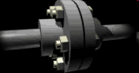
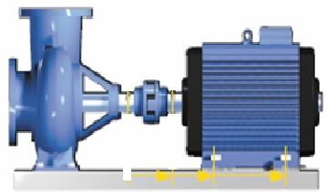Coupling is a device used to connect two shafts together at their ends for the purpose of transmitting power.
Pump
Motor
Coupling

- To provide connection of shafts of units made separately.

- To allow misalignment of the shafts or to introduce mechanical flexibility.

- To reduce the transmission of shock loads.

- To introduce protection against overloads.

- To alter the vibration characteristics.

  - Rigid
  - Flexible
  - Universal
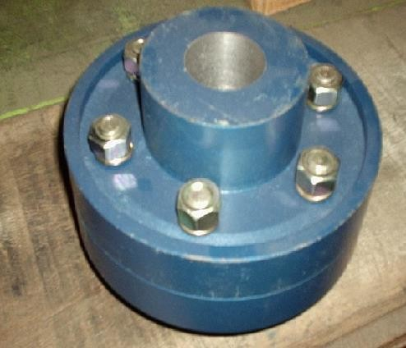
Rigid coupling

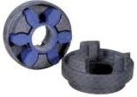
Flexible coupling

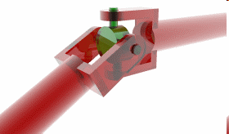

Universal coupling

- Universal coupling
- It is a rigid coupling that connects two shafts, whose axes intersect if extended.
- It consists of two forks which are keyed to the shafts.
- The two forks are pin joined to a central block, which has two arms at right angle to each other in the form of a cross.
- The angle between the shafts may be varied even while the shafts are rotating.

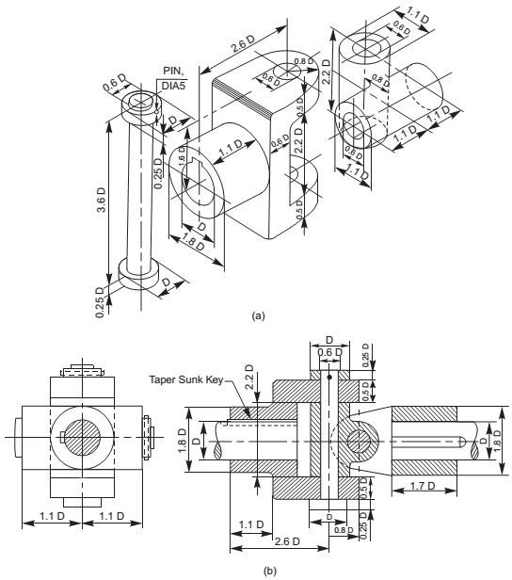

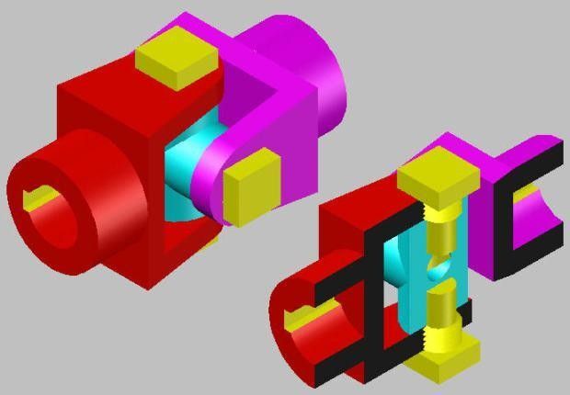

- Oldham coupling
- It is used to connect two parallel shafts whose axes are at a small distance apart.
- Two flanges, each having a rectangular slot, are keyed, one on each shaft.
- The two flanges are positioned such that, the slot in one is at right angle to the slot in the other.
- To make the coupling, a circular disc with two rectangular projections on either side and at right angle to each other, is placed between the two flanges.
- During motion, the central disc, while turning, slides in the slots of the flanges. Power transmission takes place between the shafts, because of the positive connection between the flanges and the central disc.

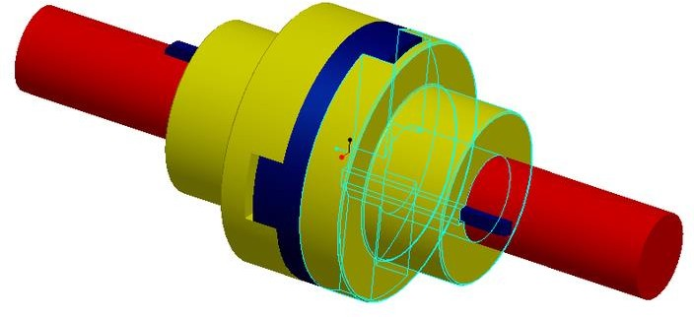

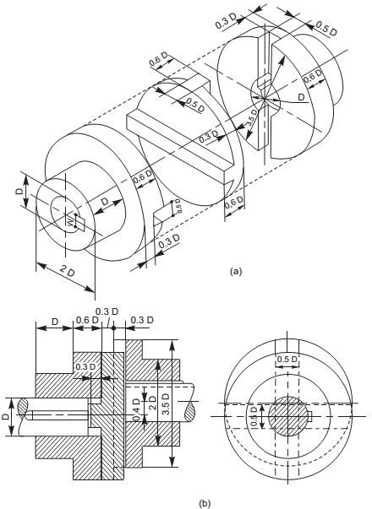

- Rotating shafts, which transmit motion and power, need to be supported on bearings.
- Long shafts, if supported only at its two ends, deflects at their centers. So
for the smooth running of the shafts, bearings are used at some intervals.
- Bushed bearing
- It is a modification of solid bearing. A bush of brass or gunmetal is press fitted inside the bearing. Shaft sits on the bush instead directly in contact with bearing.
- A grub screw or a pin inserted half inside the bush and half in the block prevents sliding or rotating of bush against bearing. The basic purpose of bush is that when bush gets worn out, it can be easily replaced instead replacing the whole bearing.
- The bolt holes in the block are made longer with semi-circular ends for
adjusting the position of the bearing.

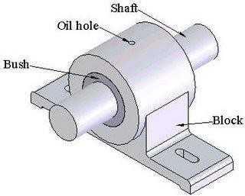

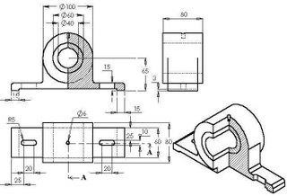

- A ball bearing is a type of rolling-element bearing that uses balls to maintain the separation between the bearing races.

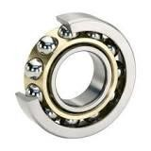
- The purpose of a ball bearing is to reduce rotational friction and support radial and axial loads.

- Roller Bearings are a type of rolling-element bearing that uses cylinders (rollers) to maintain the separation between the moving parts of the bearing (as opposed to using balls as the rolling element).
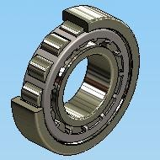
- The purpose of a roller bearing is to reduce rotational friction and support radial and axial loads.

- Footstep bearing is used to support shaft vertically. It consists of a cast iron block into which a gunmetal bush having a collar at the top is fitted.
- The shaft rests on a steel pad. The pad is prevented from rotating by a pin, inserted half inside the block and half in the pad and away from the centre.
- The collar of the bush is made hollow to serve as an oil cup for
lubrication of the bearing.

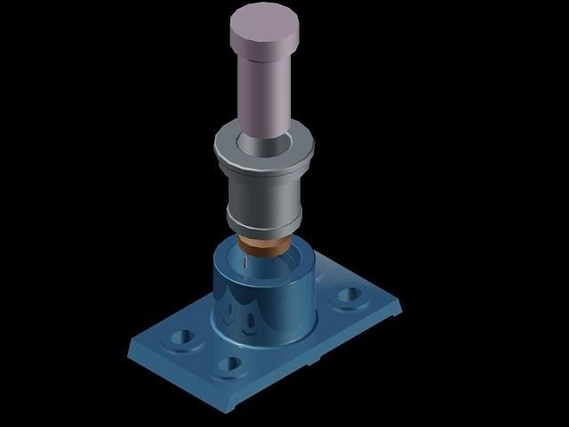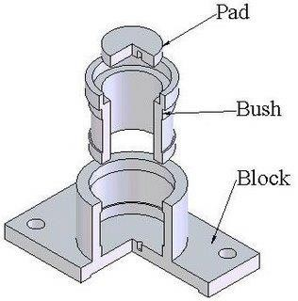

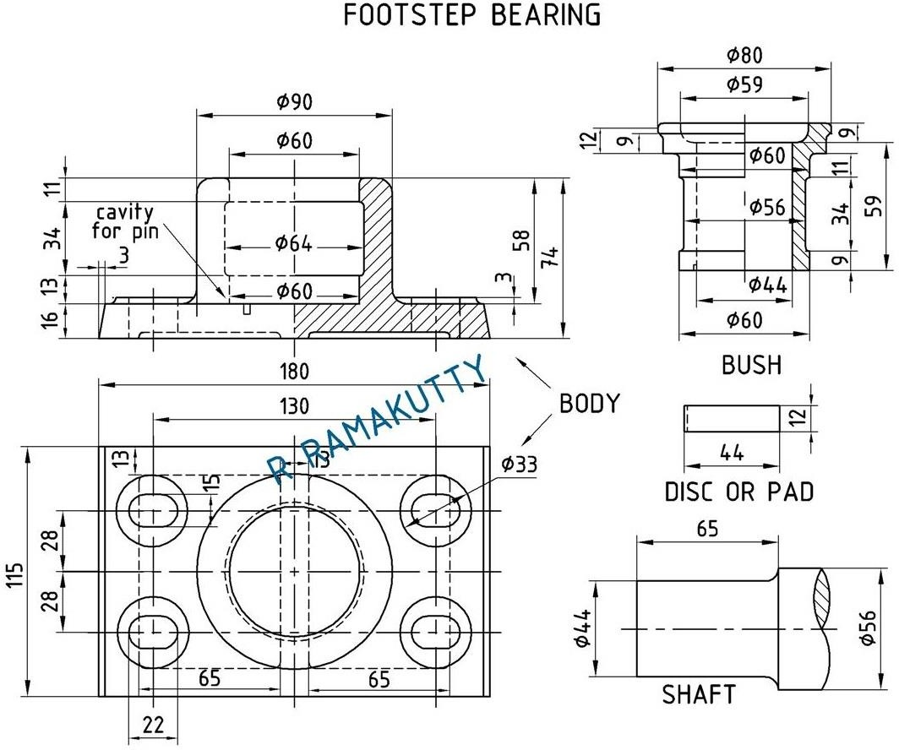

Pedestal bearings or
plummer block

Bearing consists of
- Cast iron pedestal.
- Gun metal, or brass bush split into two halves called brasses.
- Cast iron cap and two mild steel bolts.
- The rotation of the bush inside the bearing housing is arrested by a snug at the bottom of the lower brass.
- The cap is tightened on the pedestal block by means of bolts and nuts.

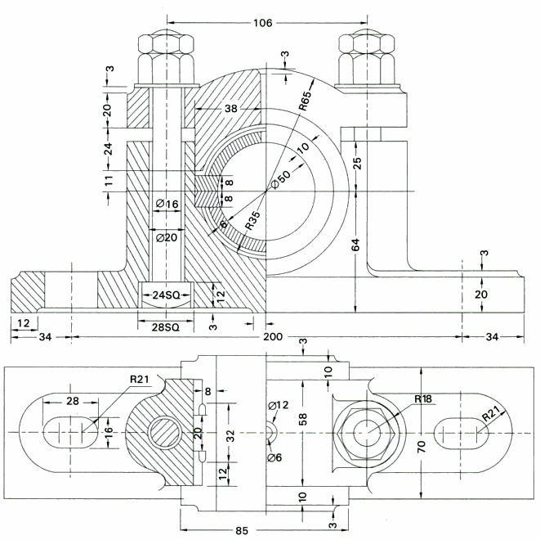

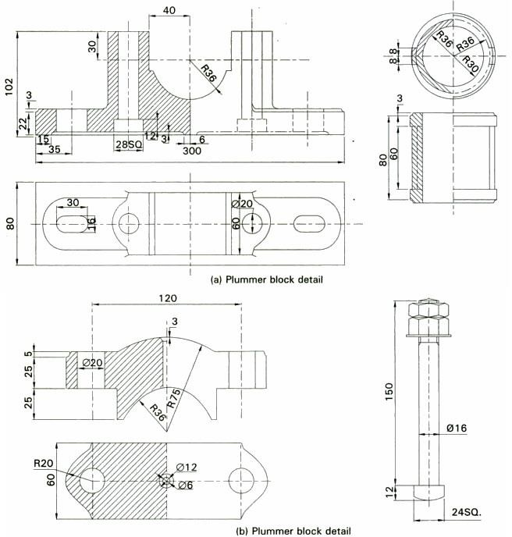

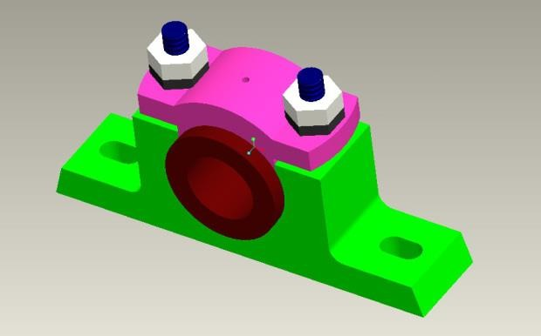

Pulleys

- Pulley is a wheel on an axle or shaft that is designed to support movement and change of direction of a taut cable or belt along its circumference.
- Pulleys are used in a variety of ways to lift loads, apply forces, and to transmit power.
- Types of pulleys:
- Speed Cone or Stepped Pulleys
- Split Pulleys
- Rope Pulleys
- V-belt Pulleys

Material used for pulleys
- Pulleys can be made from a variety of materials, including an extensive range of plastics, wood and metals.

- Steels and aluminum alloys are regularly used in industrial pulley manufacture.

Fast and loose pulley

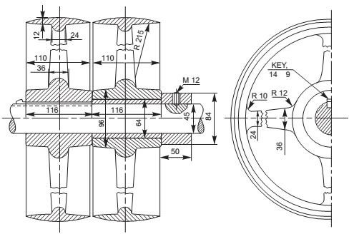

Pipe joints
- Flanged joints are used for high pressure flows and for large diameter pipes. In general they are used for plain end pipes or threaded pipes.

- Two flange components are connected by bolts at the pipe joint to prevent leakage.

Types of pipe fitting
- There are different types of pipe fitting used in piping.
- Elbow, Tee,
- Union,
- Coupling,
- Swage Nipple,
- Expansion Joint,
- Steam Traps,
- Flanges and Valve.

Expansion joints

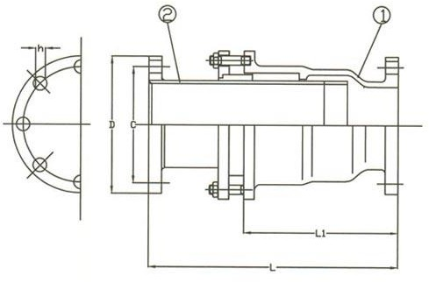

Right angle bend pipe

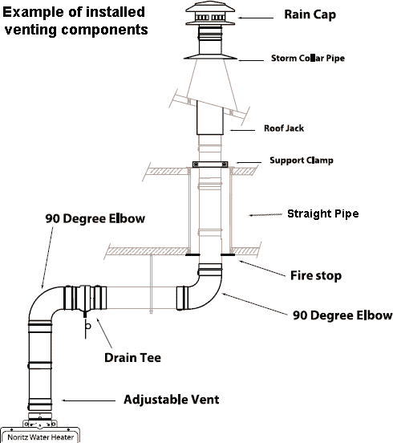

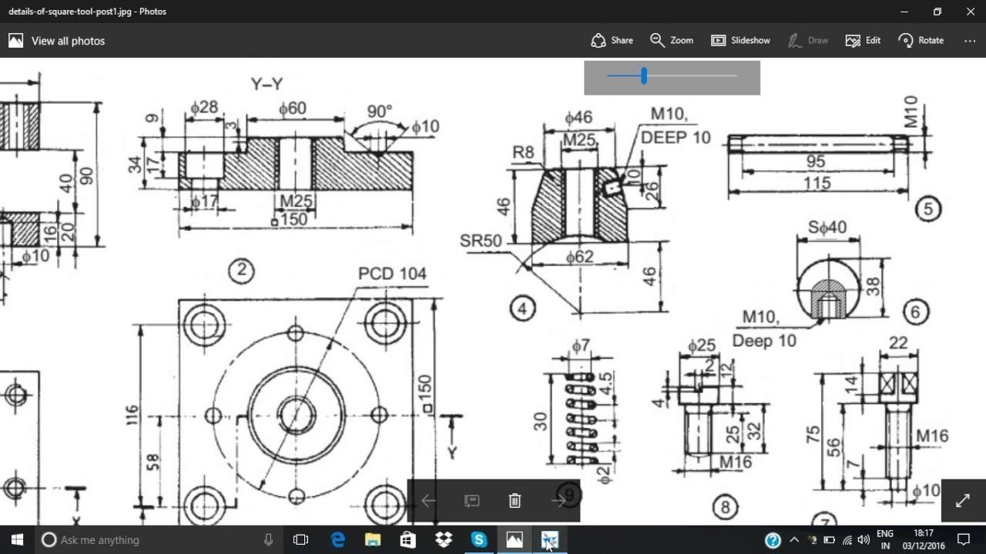

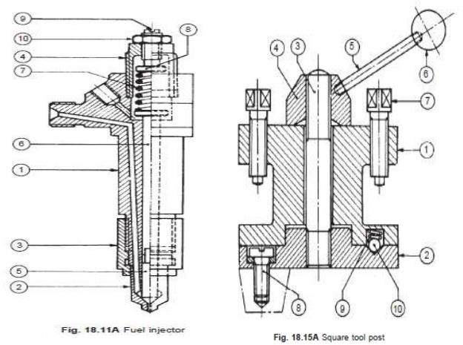

Chapter 3 Drilling Jig

Drilling jig

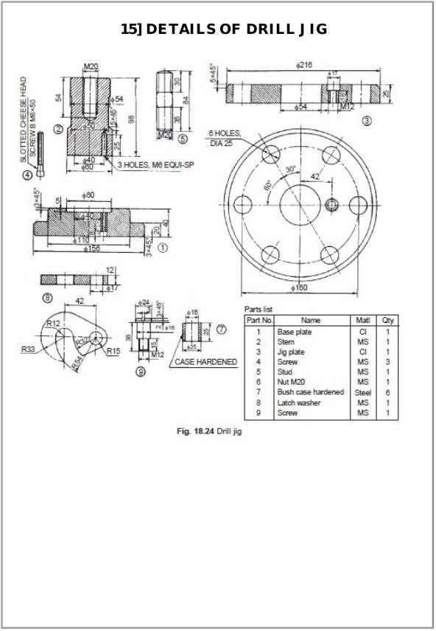

Thanks…………

