# DIGITAL NOTES FOR

**ESTIMATING AND COSTING IN ELECTRICAL ENGINEERING (ECEE)**

**Sem: 4th Branch: EE**

### ELECTRICAL ENGINEERING DEPARTMENT GOVT. POLYTECHNIC, DHANGAR

**Estimating:**

* Estimating is an art by which we can get an approximation of the material, investment involved and the time to be taken for the completion of electrical project.

**Purpose of Estimating & Costing:**

* It is necessary to know the necessary material and the cost to be incurred before starting the project.
* To ensure all the materials required for the execution of the project.
* To avoid the misuse of money.
* To save time required for completion of the project.
* To complete the project un-interruptedly.

## Elements of Estimating & Costing:

1. Performa for making estimates
2. Preparation of making material schedule costing
3. Price lists
4. Net price list
5. Market survey

## Performa for making estimates:

* Pro forma is a latin term meaning “for the sake of form”. It describes a method for finnancial calculation.
* It shows revenue projections, estimated expenses and cash flow for

completing a project.

* A simple Performa generally used for making estimate is shown in below

table:

|  |  |  |  |  |  |
| --- | --- | --- | --- | --- | --- |
| **Sr. No.** | **Description of material with complete specifications** | **Unit** | **Quantity** | **Rate** | **Amount** |
| 1. |  |  |  |  |  |
| 2. |  |  |  |  |  |
| 3. |  |  |  |  |  |

## Preparation of material schedule costing:

* It is planning of purchase of materials during different stages of the project.
* An estimator generally calculates the quantity and cost of materials at an early stage and uses these cost while executing the project.
* A simple proforma generally used for making material schedule costing is

shown in below table:

|  |  |  |  |  |  |
| --- | --- | --- | --- | --- | --- |
| **Sr.**  **No.** | **Description of material with complete specifications** | **Unit** | **Quantity** | **Supplier-1** | **Supplier-2** |
| 1. |  |  |  |  |  |
| 2. |  |  |  |  |  |

## Price list:

* By market survey, the estimator gets the price list of the material from the shopkeepers in which the shopkeepers give the retail and wholesale prices.
* This list is updated according to market rate from time to time.

## Net price list:

* Net price of an item is that price in which all the imposed taxes such as sale tax, central sales tax, excise duty and other local taxes are included.
* Normally above mentioned taxes are not included in the price list.
* Below table shows the net price list.

|  |  |
| --- | --- |
| **Name of item: 15 A switch and socket combined, 3 pin** | **Price in Rs.: 40.00** |
| Discount@10% | -04.00  Balance: 36.00 |
| Sales tax@5% | +1.80 |
| Net Price | Rs. 37.80 |

## Market survey:

* Market survey is an investigation into the state of the market for a particular product or service, including an analysis of consumer’s needs and preferences.
* Materials required for the completion of project is purchased after preparing estimate.
* Before preparing the material, market survey is conducted to ensure that

the material is purchased at a lower price.

* A market survey gathers information about the price of various products from different firms.
* The purpose of a market survey is to provide the price variation of different

firms and also the quality offered by the different firms.

### Overhead charges:

* Overhead charges incurred daily such as salary of administrative staff, rent, travelling expenses, advertisements, insurance, electricity, water etc.
* Normally 10-15% of the total estimated material and labour expenses are spent on overhead expenses.
* The overhead expenses are divided into two categories:
* (a) Maintenance overhead charges
* (b) Administrative overhead charges

1. **Maintenance overhead charges:**

* This expenditure is on keeping the machines in working order i.e. expenditure involved on spare parts of the machines which normally occur due to wear and tear of machines.
* Apart from this, the water charges, house tax and depreciation charges on

the components also fall in this category.

#### Administrative overhead charges:

* Funds are required to run the administration of various departments and their employees properly and efficiently.
* The expenditure involved on functioning of the departments such as

purchase section, sale section, salaries section, accounts section etc.

## Labour charges:

* There are following two methods for the determination of labour charges:
* (a) Electrical point method (b) Fixed percentage method

#### Electrical point method:

* This very simple method for the determination of labour charges for a project.
* In this system, the total number of points in the building are counted including installation of main board and switch boards.
* The labour rate per unit is paid to an approved contractor in the case of govt. buildings and to an individual trained wireman in case of private buildings.
* The total labour cost can be calculated from the following table:

|  |  |  |  |  |
| --- | --- | --- | --- | --- |
| **Sr.**  **No.** | **Description of work** | **No. of points** | **Rate per point in Rs.** | **Total rate in Rs.** |
| 1. | Main Board | 1 | 20 | 20 |
| 2. | 2 Switch board@ 2 points for each switch board | 4 | 20 | 80 |
| 3. | Light/fan points | 8 | 20 | 160 |
| Total labour charges | | | | 260 |

#### Fixed percentage method:

* In this system a fixed percentage of the total material cost is counted towards labour payment.
* This percentage may be 15%, 20% or 25% depending upon type of wiring.
* The payment of labour is calculated from the table given below:

|  |  |  |  |  |
| --- | --- | --- | --- | --- |
| **Sr.**  **No.** | **Description of material** | **Material cost in Rs.** | **Rate (% of total material)** | **Labour cost in Rs.** |
| 1. | Total cost of wiring material | 6500.00 | 15% | 975 |

**Contigencies:**

* During completion of the project, there can be certain emergency expenses which can not be calculating while calculating the material cost and labour expenses for the project.
* These additional emergency expenses may be due to any reason such as increase in cost of material or labour rates etc. Such additional expenses are called contigencies.
* For this, 3-5% of the material cost and labour cost is estimated to be on

contigencies.

* This amount fully compensates the additional material cost, labour cost and

other allied expenses which could not be considered.

* These expenses may be due to natural calamities such as floods, earthquake, storms etc.

## Purchase system:

The following sequence of procedure is adopted to purchase the material

desired in completion of the project:

1. Requisition
2. Call of quotations
3. Comparative statements
4. Purchase order
5. Inspection of material
6. Release of payment as per terms and conditions

#### Requisition:

* The demand of various items of material and quantity is obtained from various departments of the project in hand.
* The list of items should consist of complete specifications of each item

and the quantity required.

* The list prepared is finally sent to the purchase department.
* The list is to be submitted on a form called requisition.

## Call of quotations:

* After receiving requisition from various departments, the purchase department issues letters to several registered suppliers for calling rate list.
* Issuing registered postal letters to various reputed suppliers for their

competitive rates is called “calling of quotations”.

* The quotations are called in two ways:

1. By issuing individual letters by registered post letters to suppliers.
2. By news paper advertisements which is called tender notice.

## Comparative statements:

* After opening the quotations/tenders, the purchase clerk prepares a comparative statement on a form available in the office.
* The aim of preparing comparative statement is to make a comparison of

rates quoted by different suppliers.

* A committee of purchase officer, technical advisor and an account officer is constituted to examine in detail, the rates and terms of supply offerred by each supplier.
* The lowest rates offered by each firm are marked for issue of supply order after ensuring that the material offered for supply is exactly as per specifications.

## Purchase order:

* If the purchase officer has to placed orders for large scale purchases after approval of quotations, then the administrative officers and accounts officers approval is necessary so that necessary funds are made available before issue of supply order.
* The supplier selected above is issued purchase order for supply of material strictly as per quotations offered by the party on terms and conditions laid down on the quotations form.
* If the supplier fails to supply the material or violates the terms and conditions, the earnest money deposited by the supplier is forefitted.

## Tender:

* An offer in terms of rates made by the supplier or manufacturer on a prescribed form enclosed in a sealed envelope, in reply to a tender notice for supply of material on the basis of some terms and conditions is called tender.
* Some money is deposited along with the tender which is called earnest

money.

* The earnest money is a guarantee by the tenderer that the party is bound to supply the material if its tender is found to be competitive but on pre- determined conditions only.
* The earnest money is sometimes called security deposit.

## Earnest Money:

* It is the money which is deposited by the tenderer with the officer who has issued the tender notice as a guarantee to supply the material and also abide by the terms and conditions laid down in the tender notice on acceptance of his tender.
* The earnest money in the form of demand draft payable in favour of the

officers is deposited along with the tender form.

* The earnest money is refunded back to unsuccessful tenderer and adjusted in the security deposit of the successful tenderer.

## An example of tender notice:

A detailed example of tender notice is provided below:

#### Haryana State Electricity Board

**Office of the Superintending Engineer (Purchases) 132 KV Grid Sub- Station**

**Panchkula (Haryana) Tender Notice**

**No. 2018/PK/Har/108 Dated: 08.04.2018**

1. Sealed tenders are invited for the purhase of 132/33 KV transformer for installation at grid sub-station on behaf of Superintending Engineer (Purchases) HSEB Panchkula.
2. Earnest money should be in the form of demand draft in favour of Superintending Engineer (Purchases) Haryana State Electricity Board Panchkula.

|  |  |  |  |  |  |  |  |
| --- | --- | --- | --- | --- | --- | --- | --- |
| **Sr.**  **No.** | **Description of material** | **Quantity** | **Approx cost (Rs.)** | **Earnest money (Rs.)** | **Cost of tender form (Rs.)** | **Class of contractor eligible** | **Date of opening of tender with time** |
|  | Power |  |  |  |  |  |  |
|  | transformer |  |  |  |  |  |  |
|  | 20 MVA 3- |  |  |  |  |  |  |
| 1. | phase, 50 Hz,  132/33 KV  with all protective | 20 Nos. | 32.5  lac | 5000/- | 50 | Class I to class V | 12-05-  2018  3 p.m. |
|  | and tap |  |  |  |  |  |  |
|  | changer |  |  |  |  |  |  |
|  | components |  |  |  |  |  |  |

1. The tenders will be opened in the office of Superintendent Engineer (Purchases) Panchkula on date and time already mentioned in the tender form in the presence of Superintendent Engineer and two other senior officers authorized by Chief Engineer.

#### Terms & Conditions:

1. The number of power transformers to be purchased can be increased or

decreased depending upon situation.

1. The number given in the tender form is just an estimated requirement.
2. No tender without the earnest money can be accepted.
3. The responsibility of damage to the transformer during transportation will be that of the supplier/contractor.

## Types of wiring:

1. Cleat
2. Batten
3. Casing capping
4. Conduit wiring

# Cleat Wiring

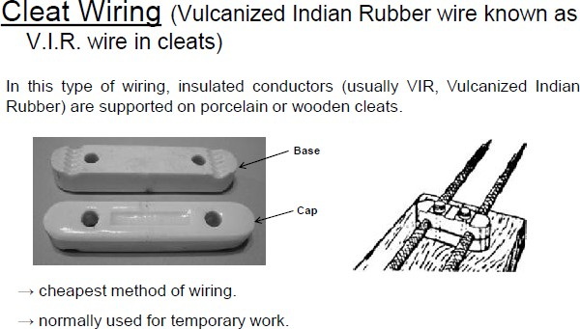

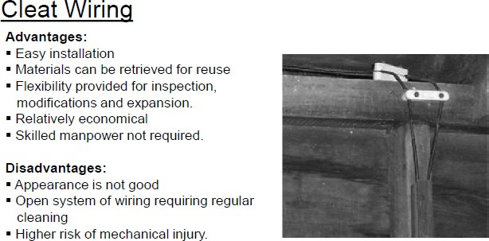

* 1. **Batten Wiring**

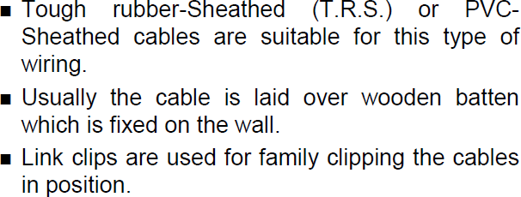

**Installing Batten Wiring**

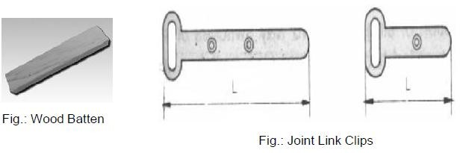

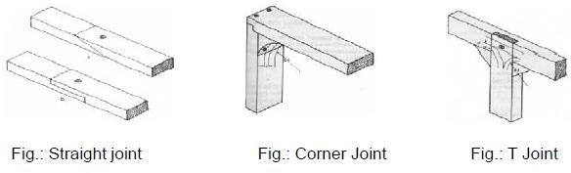

* 1. **Casing capping Wiring**

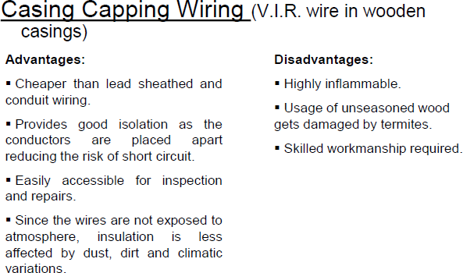

**Installing casing capping Wiring**

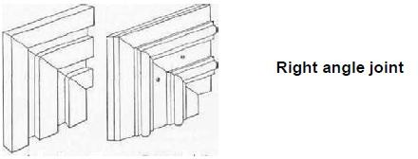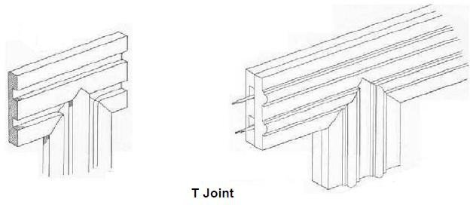

* 1. 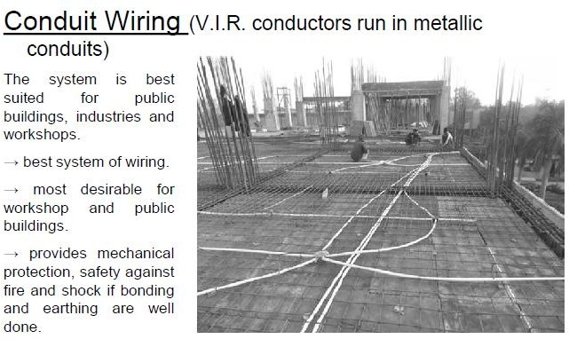**Conduit Wiring**

**Conduit Accessories**

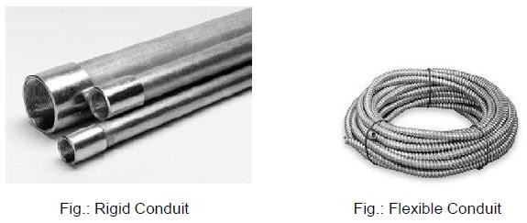

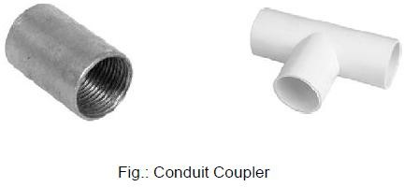

**Conduit Accessories**

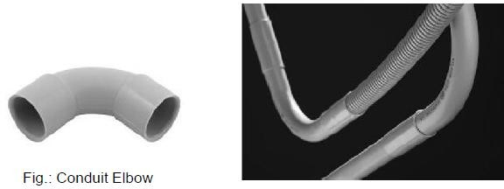

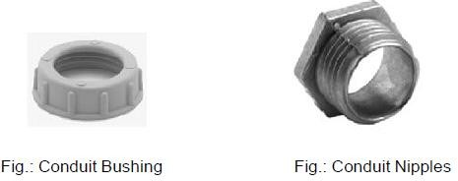

**Conduit Accessories**

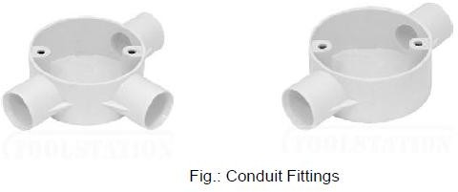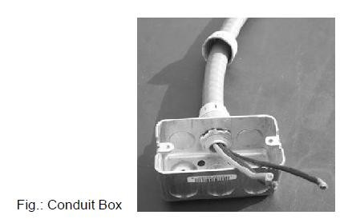

**Installing Conduit Wiring**

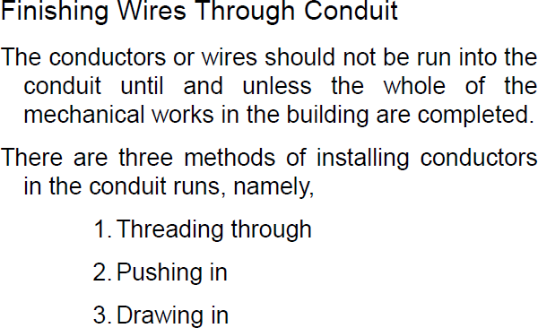

**Installing Conduit Wiring**

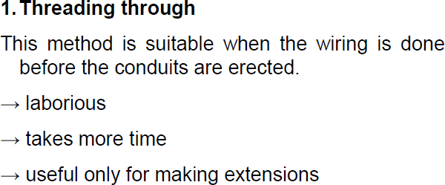

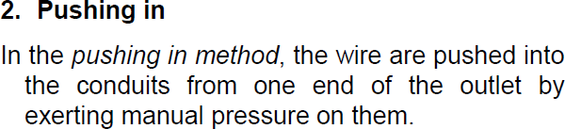

**Installing Conduit Wiring**

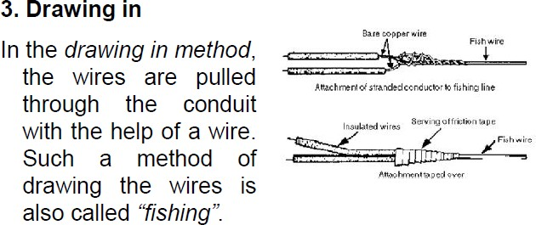

**Comparison of different wiring systems**

|  |  |  |  |  |  |
| --- | --- | --- | --- | --- | --- |
| **Sr.**  **No.** | **Particulars** | **Cleat Wiring** | **Wood casing capping wiring** | **Batten or TRS wiring** | **Concealed conduit wiring** |
| 1. | Cost | Very low | Medium | Low | Very costly |
| 2. | Voltage | Low | Low | Low | Low or medium |
| 3. | Life | Very short | Fairly long | Long | Very long |
| 4. | Protection against fire | Poor | No | Fair | Very good |
| 5. | Mechanical  protection | No | Fairly good | Good | Very good |
| 6. | Appearance | Not good | Fair | Good | Very good |
| 7. | Type of labour required | Semi-skilled | Highly skilled | Skilled | Highly skilled |
| 8. | Addistion or alteration to existing wiring | Very easy | Difficult | Easy | Most difficult |

**Wiring Schemes-Joint Box System**

* This is made possible by connecting the lamp and its controlling switch in series, the ends of which are then connected through T joints to the two lines coming from the main distribution board.
* In this system joints are made in joint boxes.
* The schematic diagram for this is shown below.

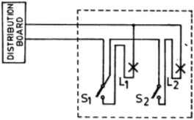

# Wiring Schemes-Looping In System

* The main advantage of this system is that no tappings are taken directly from the main wire, and therefore no joint boxes are used.
* The length of wire required in this system is more than the length required in the joint box system.
* The schematic diagram for this system is shown in below figure.

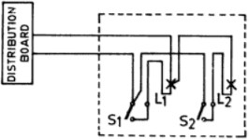

# Selection of wires and cables

The following points must be taken into account for selection of wires and cables:

#### Minimum size of conductor:

* The minimum size of copper conductor in use is 1/1.12 mm based on permissible wattage in the sub—circuit i.e. 800 watts or 10 electrical points.

#### Current carrying capacity:

* The current when passes through a wire, a certain amount of heat may be produced which results in increase in temperature of conductor.
* The wires are therefore selected keeping into consideration that the size of the conductor is sufficient to carry the maximum current.

#### Voltage drop:

* Before deciding a proper size of cable to be used in a circuit due consideration must be given to the voltage drop.
* Fall of pressure or voltage in an electric circuit is called a voltage drop.
* The voltage drop will take place when the current flows through the wires and same should be as low as permissible and economical as per ohm’s law, the voltage drop can be determined as the resistance is inversely proportional to area, so the voltage drop will be less if the conductor cross-sectional area is more.

#### Metal of the conductor:

* The metal of the conductor is an important factor for determining the size of the conductor.
* For instance, the conductor of copper will withstand more current as

compared to aluminum due to their different conductivity.

* The copper conductor are not used due to higher cost of copper but aluminum conductors are in massive use due to economy factor ignoring its comparatively low conductivity.