NON-CONVENTIONAL ENERGY SOURCE

SEMESTER-2nd
BRANCH-ELCTRICAL ENGG.

LEARNING OUTCOMES
After undergoing the subject, the students will be able to:
- Explain the importance of non-conventional energy sources for the present energy scenario.
- Classify various non-conventional sources of energy
- Explain principle of solar photovoltaic energy conversion and the applications of solar energy in different fields.
- Explain basic conversion technologies of biomass, wind energy, geo-thermal, tidal energy, hydro energy and its applications.
- Explain direct energy conversion systems like magneto hydrodynamics and fuel cells and its applications.

  - DETAILED CONTENTS
- Classification of Energy Resources:
Conventional & Non Conventional Energy Resources, commercial and non-commercial energy, Roles & responsibility of Ministry of New & Renewable Energy Sources, Need of renewable energy, Targets & present status of Renewable Energy Sources in India
- Solar Energy:
Introduction, Potential of solar energy in India, Solar radiation Principle of conversion of solar radiation into heat, photo-voltaic cell, electricity generation, application of solar energy like solar water heaters, solar furnaces, solar cookers, solar lighting, solar pumping.
- Hydro Energy:
Introduction, Capacity & Potential, Hydro Power plant( Mini & Micro), Environmental & Social Impacts

- Wind Energy:
Introduction, Wind energy conversion, windmills, electricity generation from wind types of wind mills, local control, and energy storage.

- Geo-thermal Energy:
Introduction, Geo-thermal sources, Ocean thermal electric conversion, open and closed cycles, hybrid cycles. Prime movers for geo-thermal energy conversion. Steam Generation and electricity generation.
- Tidal Energy
Introduction, Capacity & potential, Principle of tidal power, Classification of tidal power plant

- Ocean Energy
Introduction, Ocean thermal energy conversation, Principle of OTEC, Prospects of OTEC in India.

- Fuel Cells
Fuel Cell definition, Difference between batteries & fuel cell, Principle of working of fuel cell, Types of fuel cell, Power generation of fuel cell, Conversion efficiency.

- Energy Storage
Need of energy storage,Different methods of energy storage,Flywheel storage, Superconducting energy storage system,Capacitor,Battery & Super capacitor, Comparison & application.

,
Chapter | Name | Page No. | Remarks
1 | Classification of Energy Resources | 7--12
2 | Solar Energy | 13-24
3 | Hydro-Energy
4 | Wind Energy
5 | Geo thermal Energy
6 | Tidal Energy
7 | Ocean Energy
8 | Fuel Cells
8 | Tidal Energy | 58-61
7 | Ocean Energy | 62-73
8 | Fuel Cells | 74-

CHAPTER-1 CLASSIFICATION OF ENERGY RESOURCES
Energy: - The capacity to do a work is called energy
Classification of Energy:-
    - Primary Energy sources
    - Secondary Energy sources
- Primary Energy sources
The Energy of sources which can be used directly as they appear
In nature. Example:- wood, coal, oil, natural gas etc.
- Secondary Energy sources
These sources of energy derive from transformation of primary Energy. Sources. Example: - petrol etc.

CONVENTIONAL AND NON- CONVENTIONAL ENERGY
- Conventional Energy: - The sources of energy are available to user at some cost. These are exhaustible.
Example: - coal, petrol, gas, etc.
- Non- Conventional Energy: - The sources of energy are available to user at free of cost. These are renewable.
Example:- solar energy, firewood.
Advantages of Electrical Energy over the other forms of Energy:-
Energy is the form of electrical energy is most easy to use. The following advantages of Electrical Energy:-
- It is pollution free and environment friendly.
- Electrical energy can be easily converted into other forms of energy.
- It can be easily transmitted
- Efficiency of transmission in high
- Voltage can be easily stepped up or stepped down.
- Control of appliance using Electrical energy is easy and safe.
Renewable Energy sources:-
- Solar Energy
- Wind Energy
- Tidal Energy
- Bio-Gas
- Geo- Thermal Energy
- Hydro Energy
Renewable source of Energy:- These sources of energy which are used
again and again.
Non-renewable source of Energy:- These sources of energy which do
not used again and again.
Role & Responsibility of Ministry of New & Renewable Energy:-

- Technology Mapping and Benchmarking
- Identify Research, Design, Development and Manufacture thrust areas and facilitate the same
- Lay down standards, specifications and performance parameters at par with international levels and facilitate
- industry in attaining the same
- Align costs of new and renewable energy products and services with international levels and facilitate industry in attaining the same
- Appropriate international level quality assurance accreditation and facilitate industry in obtaining the same
- Provide sustained feedback to manufacturers on performance parameters of new and renewable energy products and services with the aim of effecting continuous upgrade so as to attain international levels in the shortest possible time span

Needs of Renewable source of Energy:-

- Renewable energy offers a range of benefits including offering a freely available source of energy generation. As the sector grows there has also been a surge in job creation to develop and install the renewable energy solutions of tomorrow. Renewable sources also offer greater energy access in developing nations and can reduce energy bills too.
- Of course, one of the largest benefits of renewable energy is that much of it also counts as green and clean energy. This has created a growth in renewable energy, with wind and solar being particularly prevalent.
- However, these green benefits are not the sole preserve of renewable energy sources. Nuclear power is also a zero-carbon energy source, since it generates or emits very low levels of CO2. Some favour nuclear energy over resources such as solar and wind, since nuclear power is a stable source that is not reliant on weather conditions.
Targets & Present Status of Renewable Energy in India:-
- Union Power and New & Renewable Energy Minister R K Singh on Monday said India will achieve its 500 GW renewable energy target before the 2030 deadline. Addressing FICCI's India Energy Transition Summit 2023, Singh also said had India not lost two years due to COVID-19, the nation would have achieved 50 per cent of its power generation capacity from RE non-fossil fuels, by now.
India has 424 GW of power generation capacity which includes around 180 GW from non-fossil fuels and another 88 GW is in the works.

- We will achieve 500 GW of renewable energy (RE) well before 2030.
Singh also said India's energy transition programme is at the top in the world. The RE capacity addition is the fastest in the world.
- New and Renewable Energy Secretary Bhupinder Singh Bhalla said India added 15 GW of renewable energy in the last fiscal year (2022-23) which would be increased to 25 GW in 2023-24.
CHAPTER- 2 SOLAR ENERGY
SOLAR ENERGY: - Solar is related with sun and power or energy obtained from sun is called solar energy.
It is natural source of energy.
Types of Rays: - i.Ultraviolet Rays ii.VisibleRays iii.Infrared Rays
Principle of conversion of solar radiation into heat energy:-
It depends upon green house effect.Solar energy can produce by sunlight
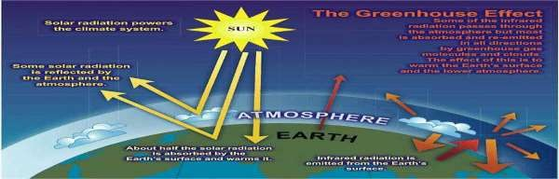Either through
direct or indirect conversions.

- The infrared rays are the main source of heat and these rays increases the temperature of earth this effect is known as Green house effect.
PHOTO-VOLTAIC CELL:-
It is a semiconductor device which converts energy sunlight into electricity is called photo voltaic cell.
The photo voltaic means light and volt is related to E.M.F.
WORKING OF PHOTO- VOLTAIC CELL:-
When sun rays falls on top of p- type semiconductor and penetrate into lower n-type semiconductor material these sun rays(photon) absorbed by semiconductor material and generate holes electrons pair. Due to this electrical field is established. Current flows from p- type material to N- type material.

GENERATION OF ELECTRICITY FROM PHOTO-VOLTAIC CELL
As shown in figure below:- how electricity is generated in photo voltaic cell.
It consists of:- 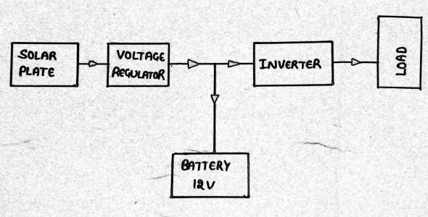
- Solar plate.
- Voltage regulator
- Inverter
- Battery 12v
- Load
(note:-voltage of one solar cell is 0.39 approx)

APPLICATION OF SOLAR ENERGY
- Solar water heater:-It is a device by which water can be heated by using solar Energy.
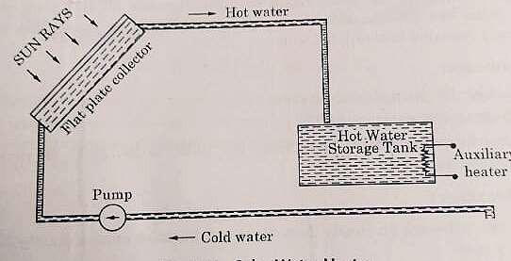
CONSTRUCTION OF SOLAR WATER HEATER

Advantages of solar water heater:-
  - Longer life spent 12-15 years
  - Heat the water at 80°C.
  - No running cost
Dis-advantages of solar water heater:-
- Initial cost is high
- Depend on whether condition. Iii.Occupies large space.

- Solar furnace:-A solar furnace is a structure that uses concentrated solar power to produce high temperatures, usually for industry. Parabolic mirrors or heliostats concentrate light (Insolation) onto a focal point.
CONSTRUCTION OF SOLAR FURNACE :-

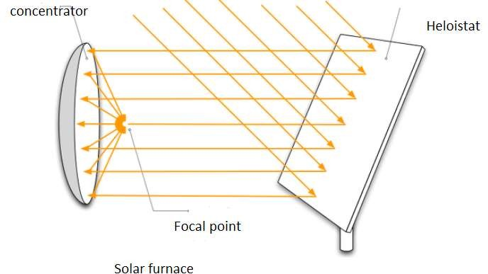

Solar cooker :-A solar cooker is a device that uses sunlight from energy. They use no fuel and cost nothing to run.
They also help slow deforestation and desertification. Another benefit of solar cooking is that unlike cooking with fire, Solar cookers don't pollute the air. Solar cookers are also sometimes used for cooking outside, especially when using fire is risky or there is no fuel. The solar cooker is very useful. It is a renewable source of energy.
CONSTRUCTION OF SOLAR COOKER :-

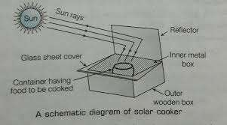

Solar lighting:- A solar light uses energy from the sun to produce light. (Solar light can also refer to natural light coming from the sun.) ... During the day, they use solar energy to charge a battery, and at night, or when it's too dark to charge the battery, the battery runs a light.
CONSTRUCTION OF SOLAR LIGHTING:-

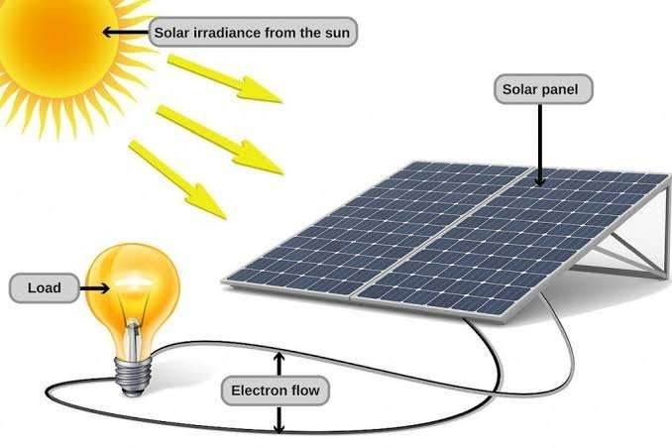

Solar pumping:- A solar-powered pump is a pump running on electricity generated by photovoltaic panels or the radiated thermal energy available from collected sunlight as opposed to grid electricity or diesel run water pumps.
CONSTRUCTION OF SOLAR PUMPING:-

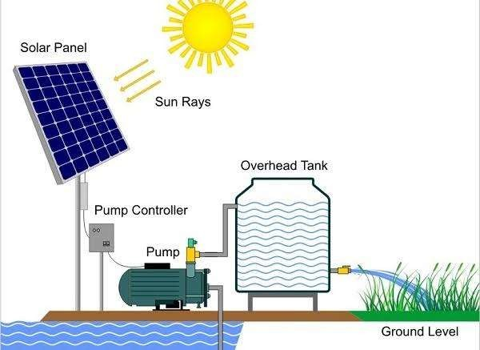

SYMBOL OF SOLAR CELL:-
